List of Credit Courses to Implemented in M.Sc. (Ag.) Soil Science Programme
at
Veer Bahadur Singh Purvanchal University, Jaunpur

Ist Semester
Code No. | Course Title | Credit Hours | Theory |  | Practical | Total
 |  |  | Mid | Final
SSAC-504 | Soil Mineralogy, Genesis, Classification and Survey | 3(2+1) | 30 | 50 | 20 | 100
SSAC-509 | Soil, Water and Air Pollution | 3(2+1) | 30 | 50 | 20 | 100
SSAC-511 | Analytical Techniques and Instrumentals Methods | 2(0+2) | 30 | 50 | 20 | 100
STAT-551 | Statistical methods | 3(3+0) | 50 | 50 | 00 | 100
 | Total Credit | 11
IInd Semester
Code No. | Course Title | Credit Hours | Theory |  | Practical | Total
 |  |  | Mid | Final
SSAC-501 | Soil Physics | 3(2+1) | 30 | 50 | 20 | 100
SSAC-502 | Soil Fertility and Fertilizer Use | 4(3+1) | 30 | 50 | 20 | 100
SSAC-506 | Soil Biology and Biochemistry | 3(2+1) | 30 | 50 | 20 | 100
STAT-552 | Experimental Designs | 2(2+0) | 50 | 50 | 00 | 100
 | Total Credit | 12
IIIrd Semester
Code No. | Course Title | Credit Hours | Theory |  | Practical | Total
 |  |  | Mid | Final
SSAC-503 | Soil Chemistry | 3(2+1) | 30 | 50 | 20 | 100
SSAC-505 | Soil Erosion and Conservation | 3(2+1) | 30 | 50 | 20 | 100
SSAC-510 | Remote Sensing and GIS Techniques for Soil and Crop Studies | 3(2+1) | 30 | 50 | 20 | 100
 | Total Credit | 09
IVth Semester
Code No. | Course Title | Credit Hours | Theory |  | Practical | Total
 |  |  | Mid | Final
SSAC-513 | Management of Problematic Soil | 3(2+1) | 30 | 50 | 20 | 100
SSAC -591 | Seminar | 1 |  |  |  | 100
SSAC -599 | Thesis/Research Work | 20 | 50 | 30 | 20 | 100
 | Total Credit | 24
 | Total Credit Hours | 56

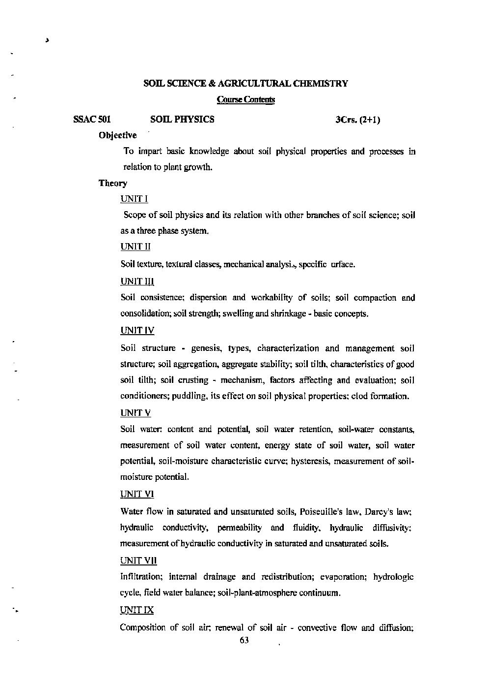

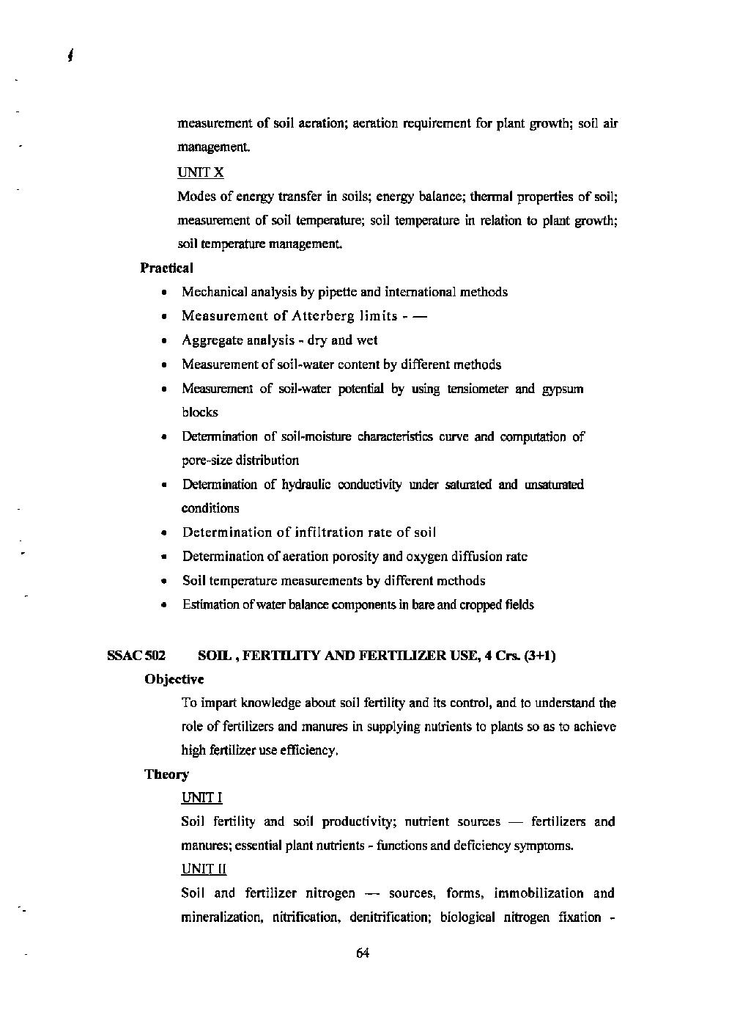

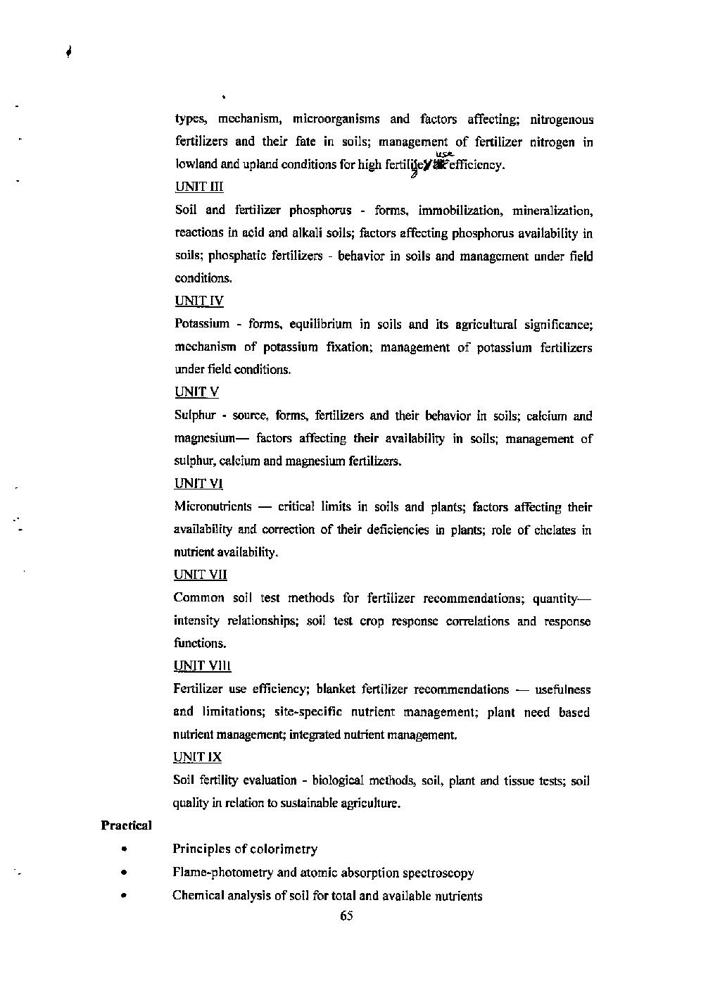

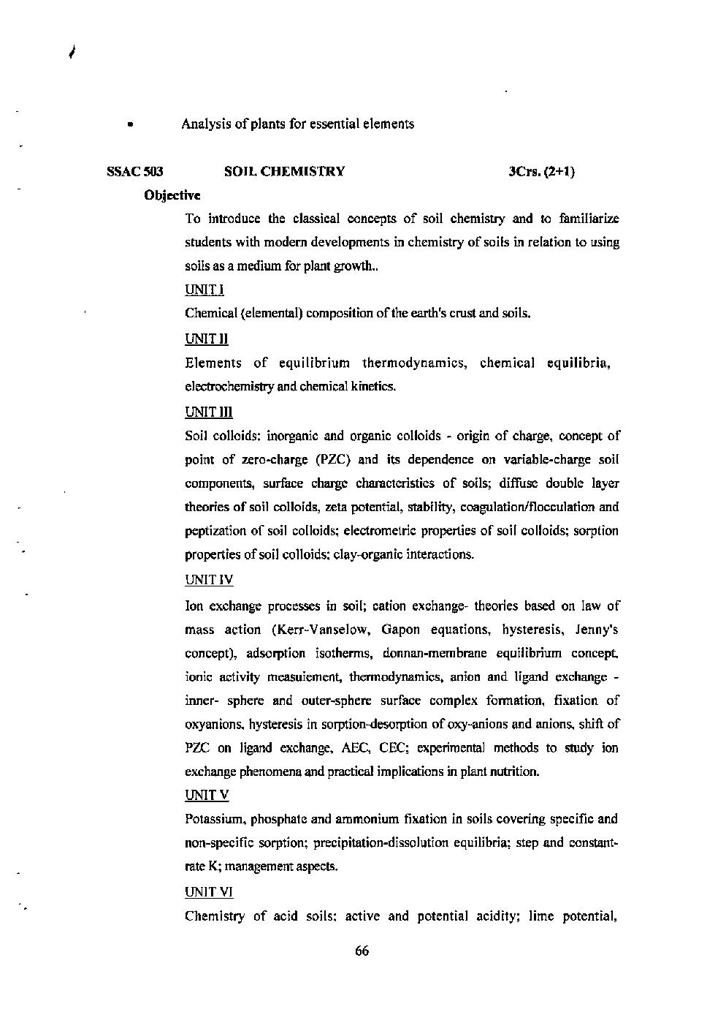

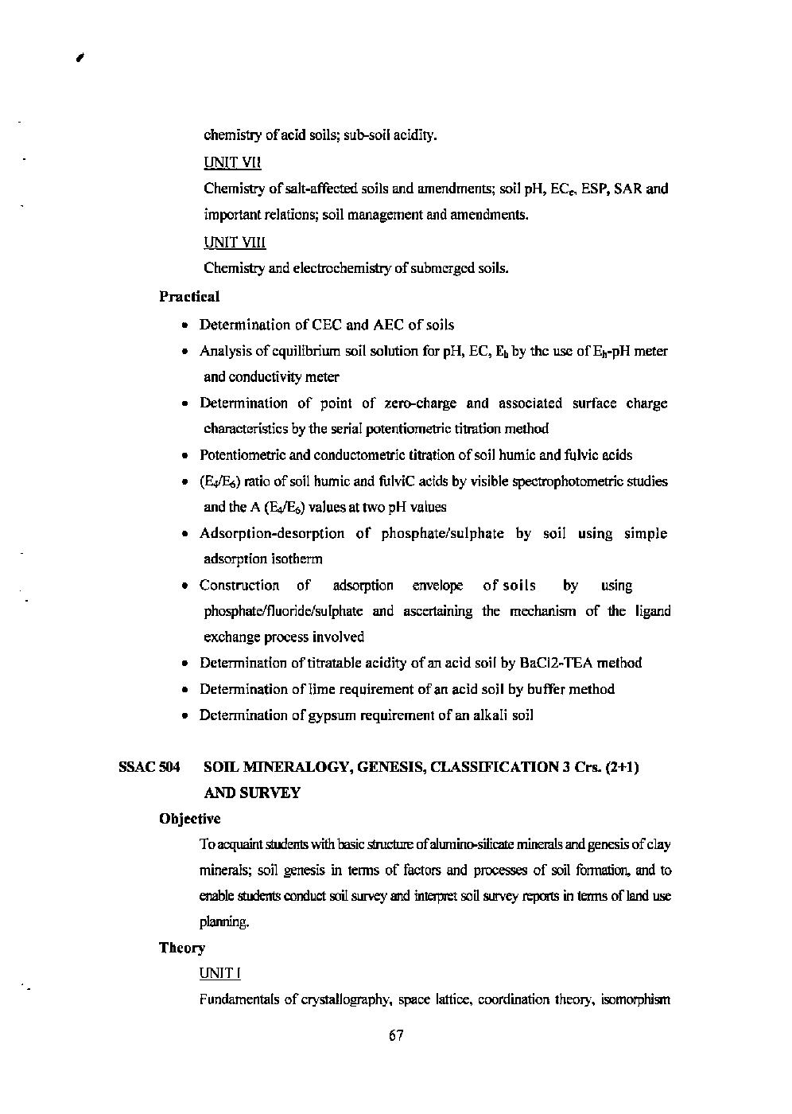

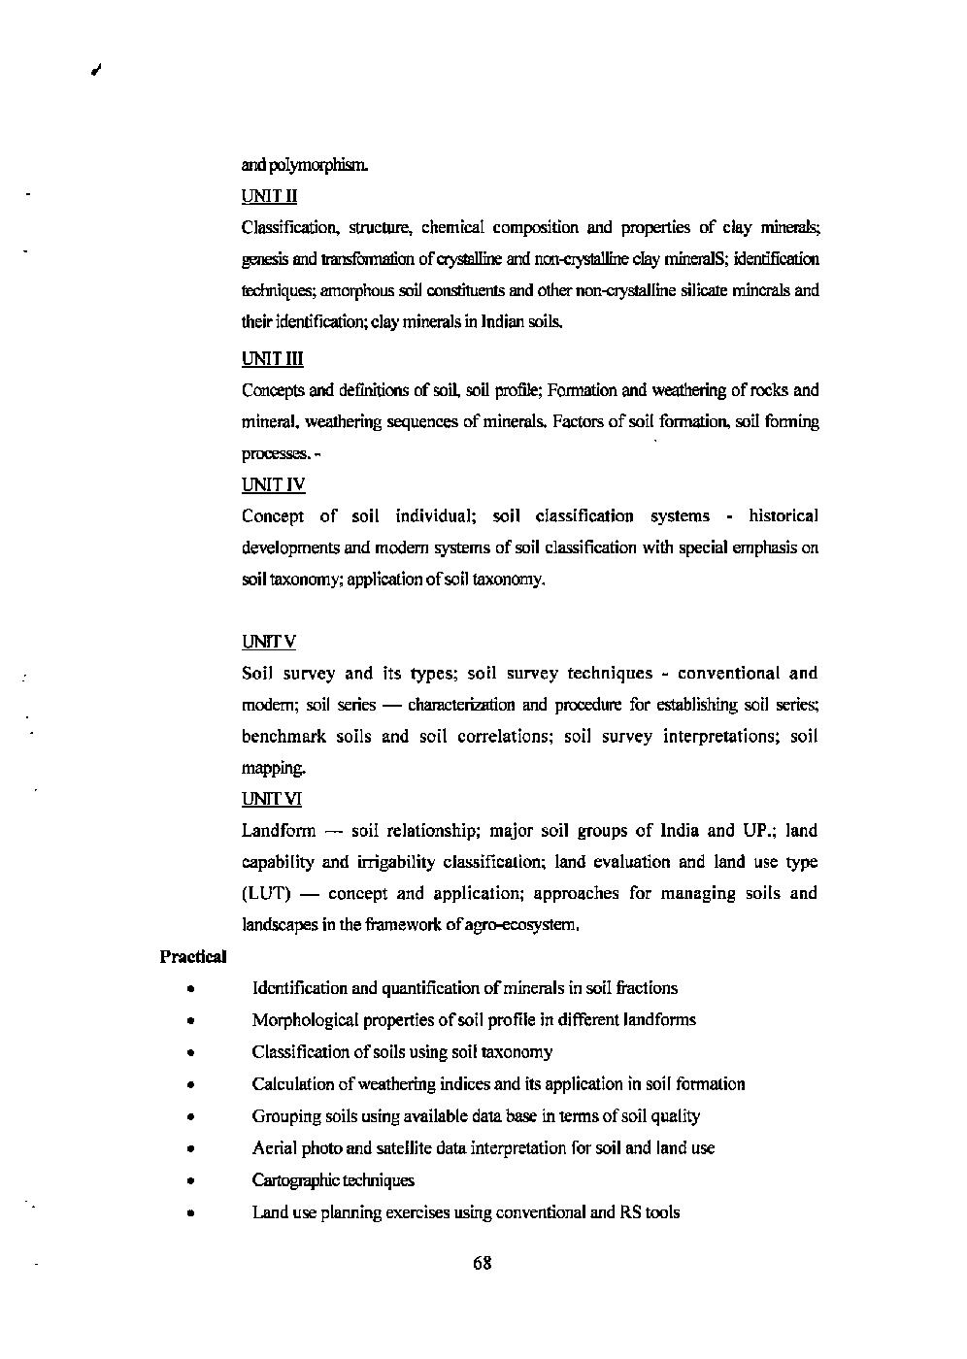

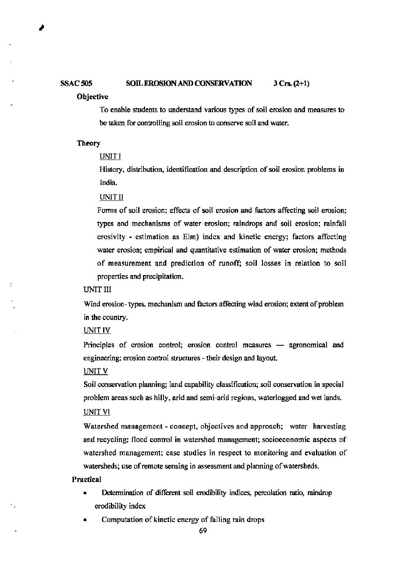

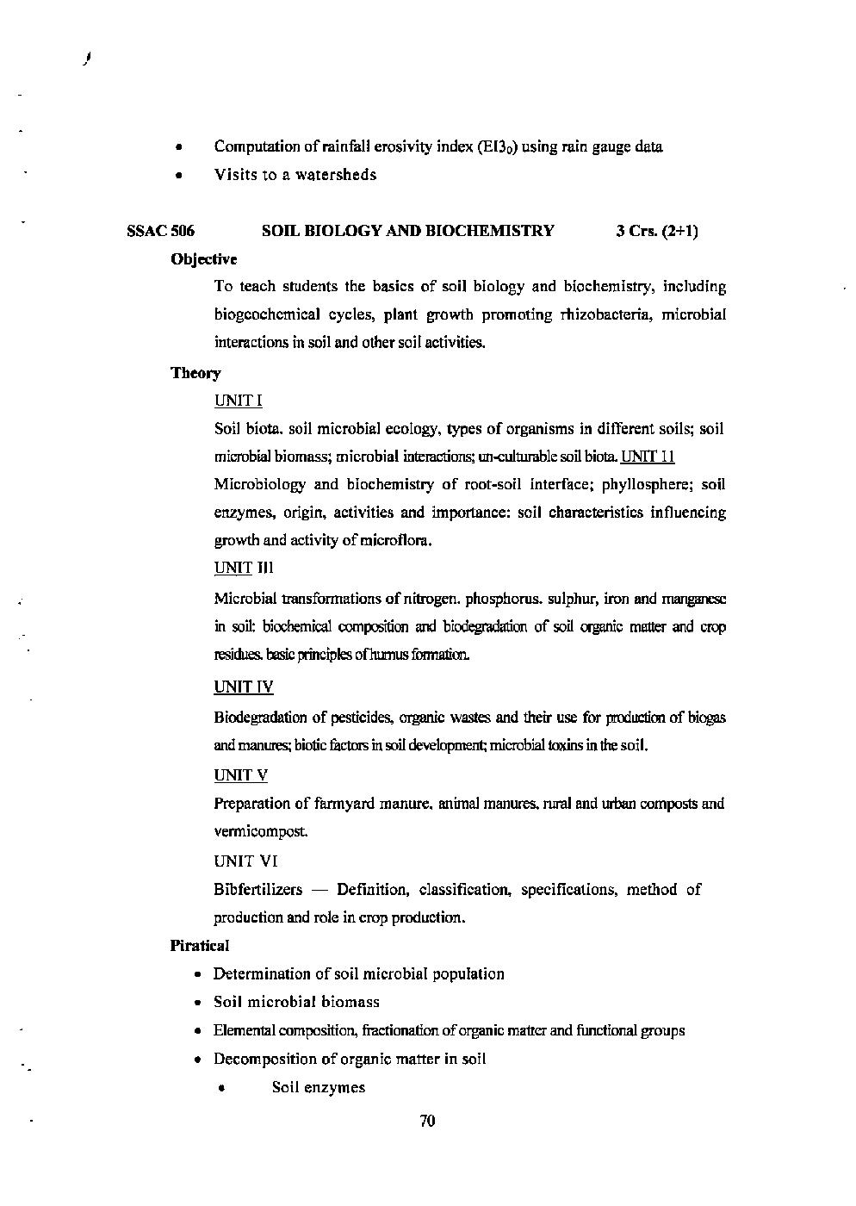

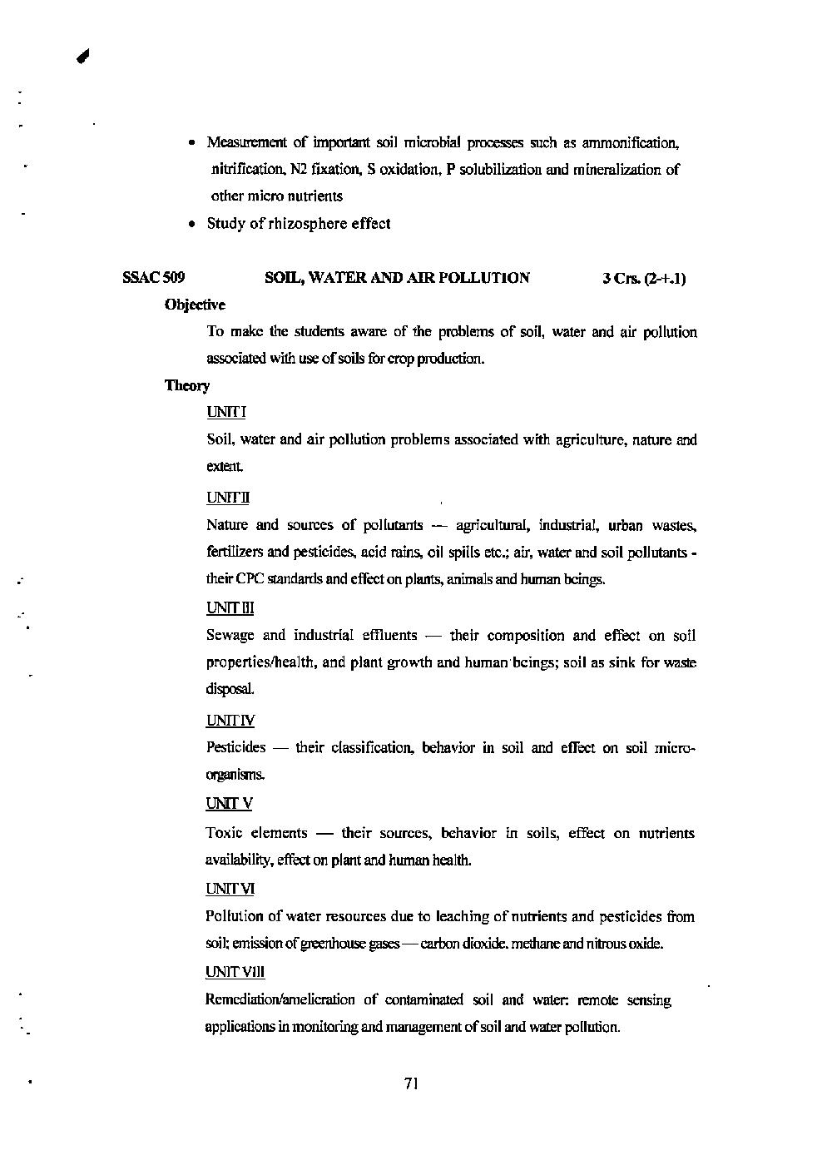

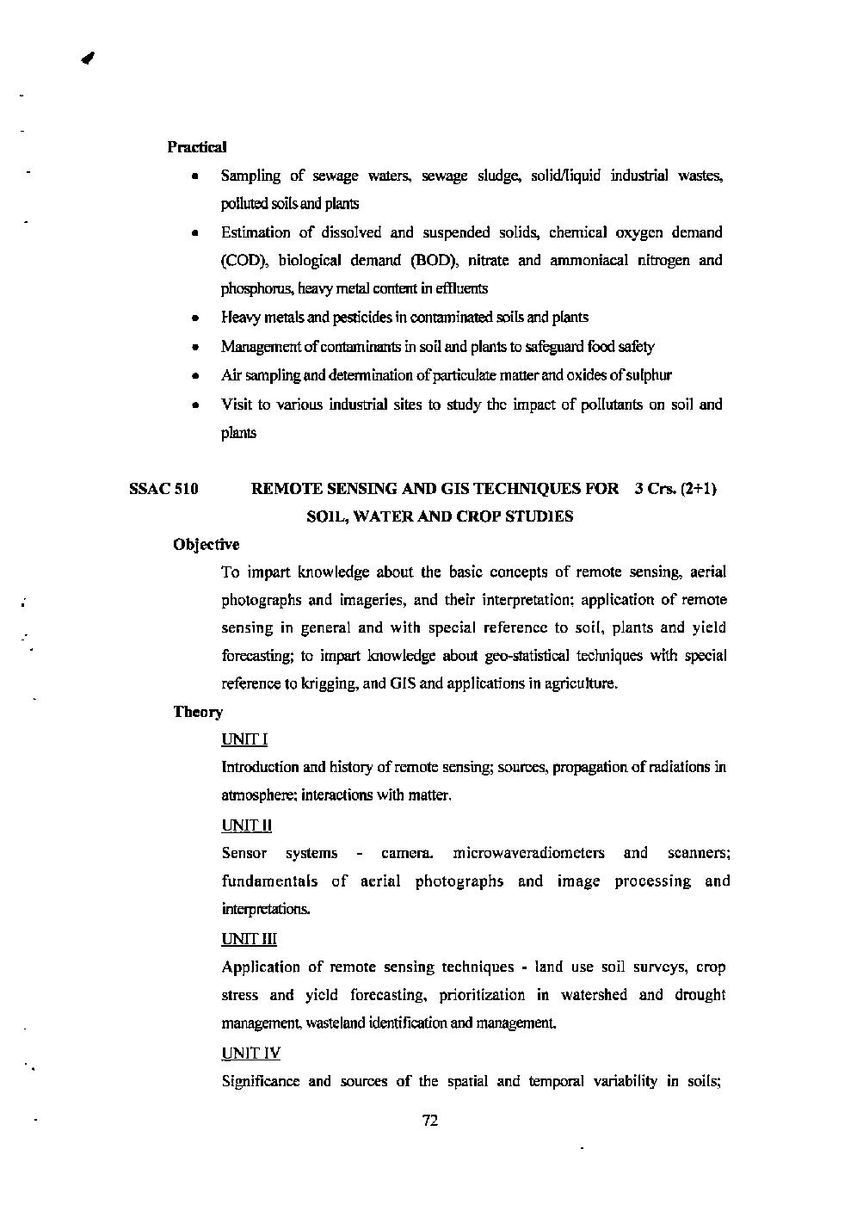

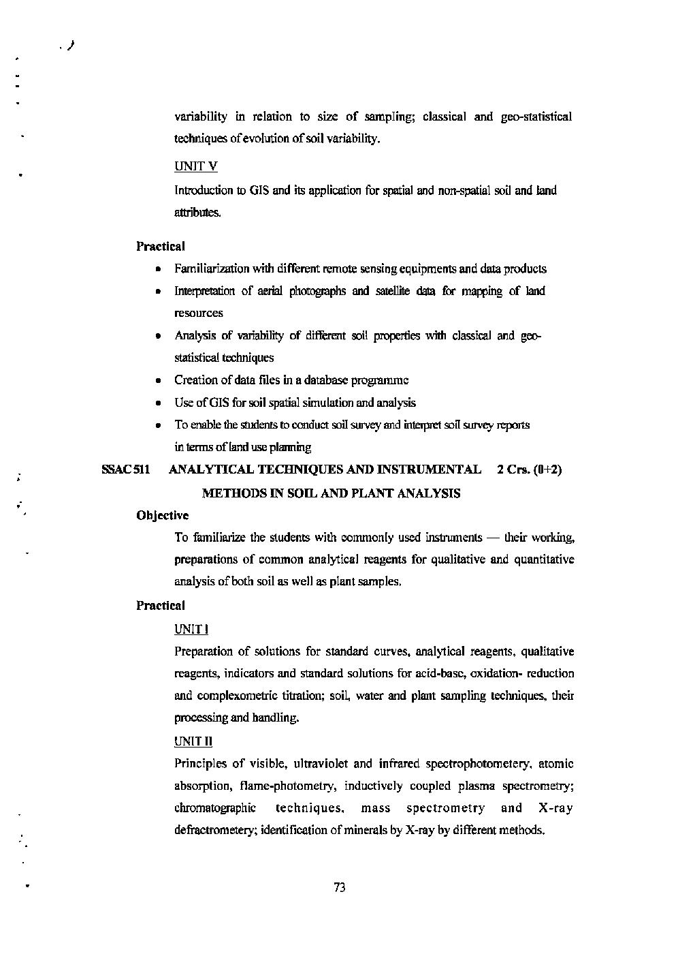

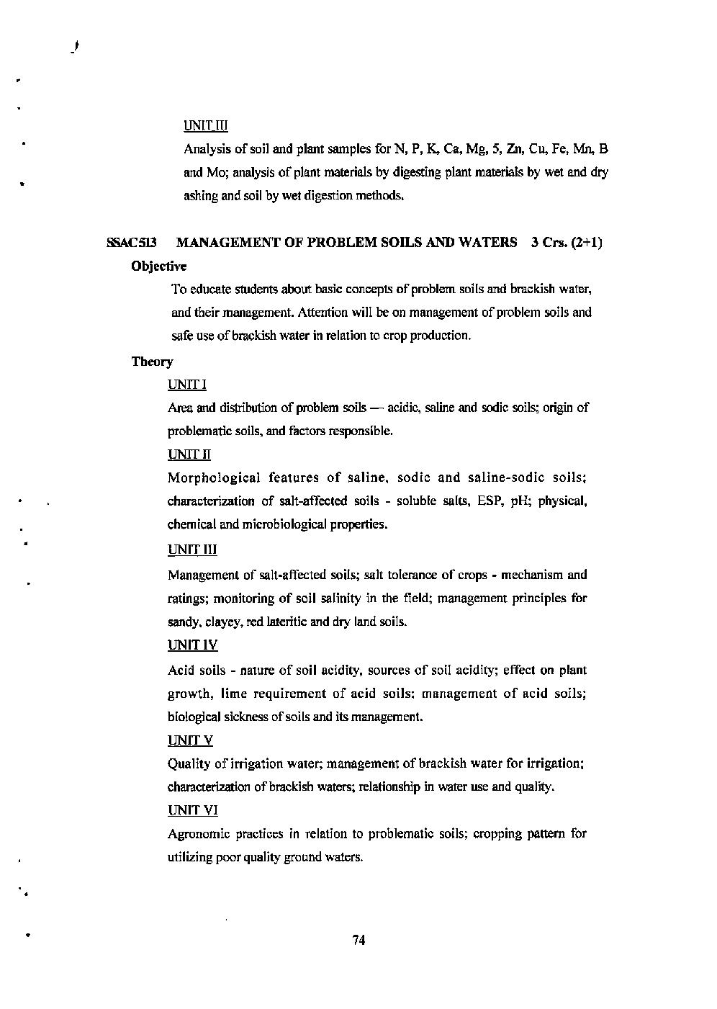

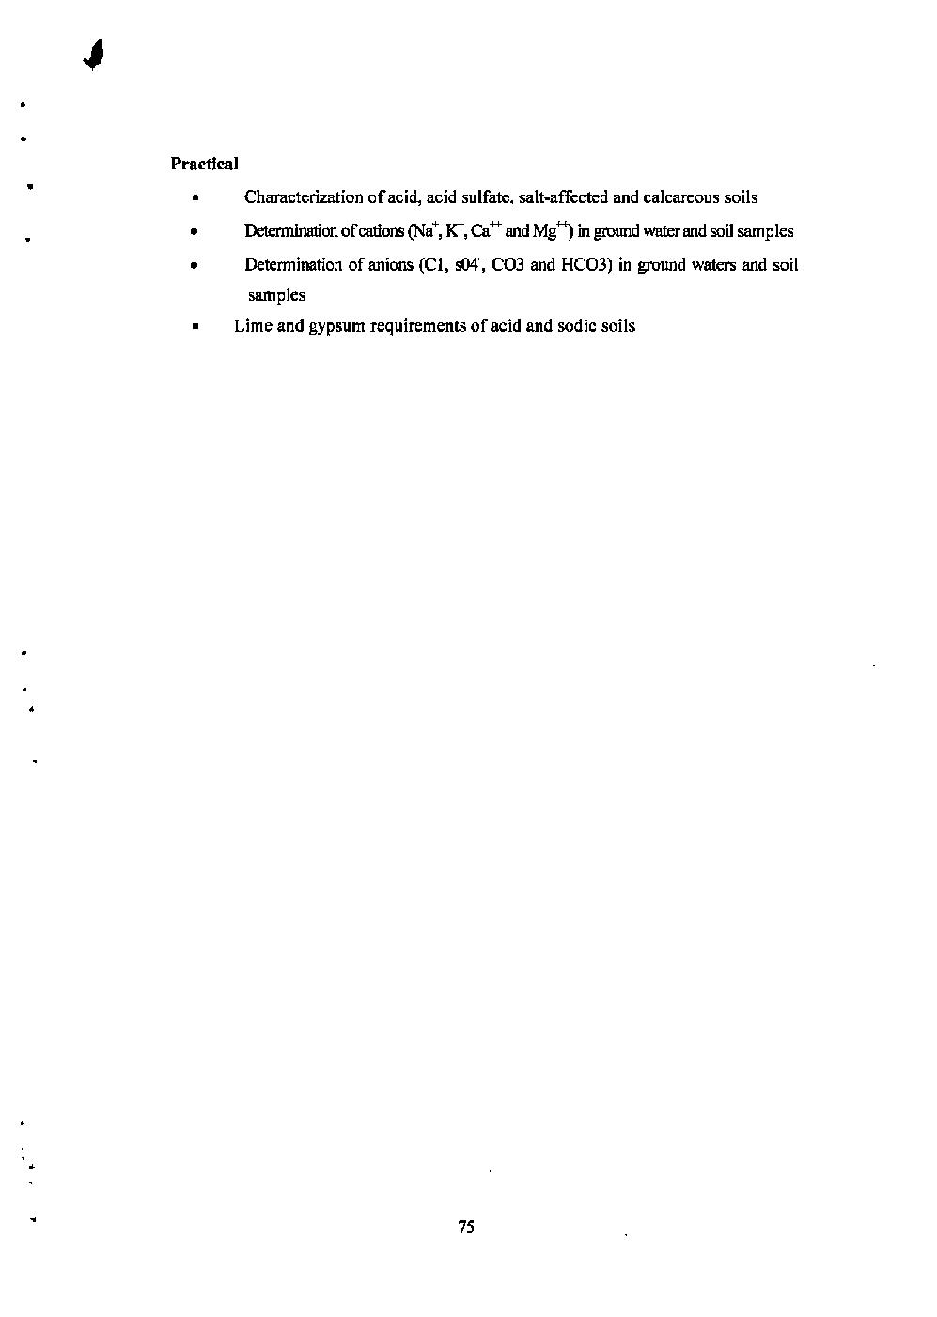

Note:
Syllabus of STAT-551 and 552 shall be common for P.G Classes
Course Title- Statistical Methods 3(3+0)
Code No.:- STAT-551
UNIT I
Summarization of data, classification and tabulation of data, Diagrammatic and Graphical Representations, utility and limitations of graphical Representation. Measure of central tendency, definition, merit, demerit, uses and properties of different measure of central tendency, measure of dispersion, moments, skewness and kurtosis.
UNIT II
Probability distribution, discrete probability distribution- Bernouli, poission, normal distribution. Theorem of addition of probability, theorem of multiplication of probability, Definition- (simple and compound events independent and dependents, mutually exclusive, complimentary events.)
UNIT III
Statistical Hypothesis, Null hypothesis, Two type of error, Statistical significance, parametric and nonparametric hypothesis, critical region, level of significance, practical application of simple test of significance viz, ‘t’ and ‘F’ test. X² test as a goodness of Fit, properties of X² distribution, conditions for application of X² test.
UNIT IV
Correlation and its test of significance, line of regression and its test of significance. Correlation, measurement of correlation, limit and range of „ correlation coefficient expressed in term of regression coefficients. Rank correlation and its computations, regression equation.

Course Title- Experimental Designs 2(2+0)
Code No.:- STAT-552
UNIT I
Principles of experimental design, precision and accuracy, advantage of replication, experimental technique. Analysis of variance, fundamental principles of analysis of variance. Critical difference, limitations of the analysis of variance.
UNIT II
Statistical analysis and advantage and disadvantage of basic design-completely randomized design, randomized block design, Latin square design.
UNIT III
Factorial concept: simple effects, main effects and interaction, factorial experiments (without confounding), Yates method. Confounding, principles of confounding in a 2³ factorial experiments. Split plot design.
UNIT IV
Missing plot technique; Bartlett’s techniques for missing plots, cross-overdesign or switch-over trials, Rotational experiments, progeny selection, compact family block design, uniformity trial, sire index, sampling in field experiments.

