A State University established under the Act of 1973
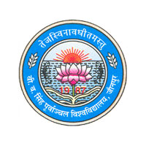

……………………………Where Excellence is Committed
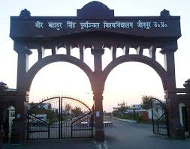
Courses Offered
MBA, MBA (Agri-Business), MBA (E-Commerce)
MBA (Business Economics)
MBA (Finance and Control)
MBA (HRD) and Master of Human Resource Development (MHRD).

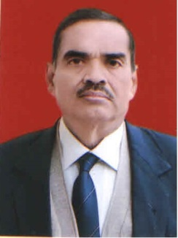
Vice-Chancellor’s Message

India’s large pool of young people are its biggest strength. The alignment of youth potential and energy with national objectives is essential for the growth of our Country. Need of the hour is value based education that not only provides knowledge, but also builds capacity for employment through holistic development. For development of the youth in eastern part of Uttar Pradesh, Veer Bahadur Singh Purvanchal University, Jaunpur plays a pivotal role. We aim to focus on the needs of future and meet them by creating an academic environment that supports teaching, learning and research. The changing pace of socio-economic development in the Country has raised aspirations in the area of higher education.
It gives me immense pleasure to invite you to join the University that excels you towards future success. With updated and innovative curriculum, we provide you both facilities and opportunity along with regular industry-academia interface.
Our University is committed to work for the cause that brings higher education accessible to the door steps of students in Purvanchal region. Make the best use of it for your personal development and growth of the region.
Prof. Peeush Ranjan Agrawal
Vice-Chancellor

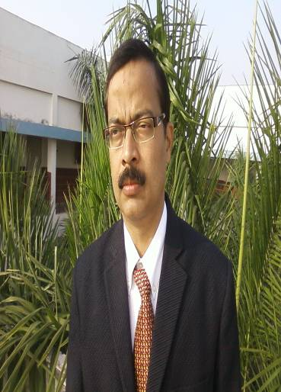
Dean’s Message
Warm greetings for all the passionate and emerging professionals!

The Information Brochure of the Faculty of Management Studies will enable the students and other stakeholders to get an overview of the courses being offered along with the eligibility, admission procedure and other relevant details. The FMS has traversed a long way to disseminate management education to all the aspiring students and I believe that the institution and its fraternity play a crucial role in igniting the minds of academic pursuant and help them to explore the treasure house of their hidden potentialities.
I am proud that the FMS drenched with the visionary gleams of academic excellence and empowerment of youth for social emancipation. We are constantly dedicated in our endeavor of providing value education to the students of this region. In terms of infrastructure we have state of the art class rooms equipped with modern teaching pedagogies, rich library, well furnished computer centre and also separate hostel for boys and girls with all the amenities like Internet facilities, power back up, gymnasium etc.
We are committed to our mission of holistic development of our students, region and the society at large. In order to be synchronize ourselves with the ever changing requirements of the corporate, we constantly upgrade and modify our course curriculum. Our students regularly go on industrial visits to get in hand experience of the corporate working and culture. In addition to this we also organize seminars, conferences, workshop and training programs by reputed resource persons from the academic and industries for the overall development of our students.
Dr Manas Pandey
Dean

VBS PURVANCHAL UNIVERSITY
ABOUT THE UNIVERSITY:
VBS Purvanchal University was established in 1987 by the Government of Uttar Pradesh (India) as an affiliating university. The nature of university is now both residential and affiliating. The University is one of its kind with the dual objective of providing and regulating education in the agricultural belt of eastern U.P. and creating avenues for industrial development in this region by conducting several professional programmes. The University has extended its community welfare programmes to the society for ensuring its participation in the socio- economic development of the region.
The contour map of the university with a sprawling campus covering an area of 172 acres, has also comprehensively changed with the coming-up of a number of academic buildings, university administrative block, hostels for men and women, residential complex for its faculty, playgrounds, library building, health centre, auditorium, community centre, shopping complex, sports stadium, and laboratories.
With around 500 colleges under its belt, the university has student strength of more than four lac in its various undergraduate courses. In addition to this the university also runs postgraduate, doctoral and post-doctoral programmes in various disciplines. Its uniqueness lies in its campus where it runs only professional and technical residential programmes.
During all these years the university has achieved a lot. The university boasts of having most enriched faculty. It has established contact with universities abroad to start academic exchange programme for its students. The apex bodies of education in India have approved the professional courses run by the universities.
The university has also the distinction of effectively managing its academic session through timely conducting examinations and declaring results despite having an enormous student’s strength of more than four lac.The University aims to become one of the best centres of higher education and in this endeavour the faculty and the staff is committed.
LOCATION OF THE UNIVERSITY:
The university is situated at Jaunpur (U.P.). This city was established during the medieval period and had been a centre of academic and cultural excellence.
Jaunpur is well connected by road, rail and air. It is around 56 kms before the holy city of Varanasi on the Lucknow-Varanasi national highway NH 56. There are two railway stations in Jaunpur (Jaunpur Junction & Jaunpur City) which connects it to the major cities like Delhi, Kolkata and Mumbai etc. The nearest airport is BABATPUR (Varanasi) which is 50 km on the Jaunpur -Varanasi highway. The airport is also connected with the major cities of the country.
Jaunpur is surrounded by various places of tourist interest like the medieval fort of Raja Jaunpur, the unique Sahi Pul and the Atala Mosque etc. Sarnath, the place where Gautam Buddha delivered his first preaching is only 60 kms away.
FACULTIES:
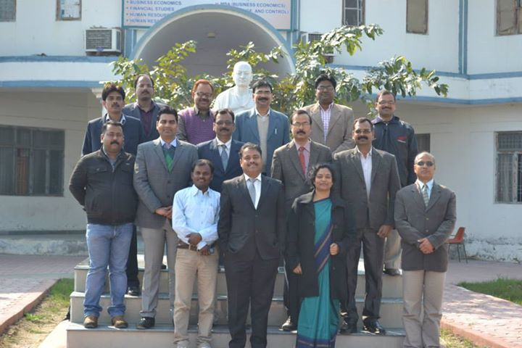
The University has a number of faculties in its campus comprising of several department, There are Faculty of Management Studies (Department of Business Management, Department of Business Economics, Department of Financial Studies and Department of HRD), Faculty of Applied Social Sciences (Department of Mass Communication, Department of Applied Psychology), Faculty of Science (Department of Bio-Technology, Department of Micro-Biology, Department of Bio-Chemistry and Department of Environmental Science), and Faculty of Engineering and Technology (Department of Computer Applications, UNS Institute of Engineering and Technology).

Faculty members of FMS

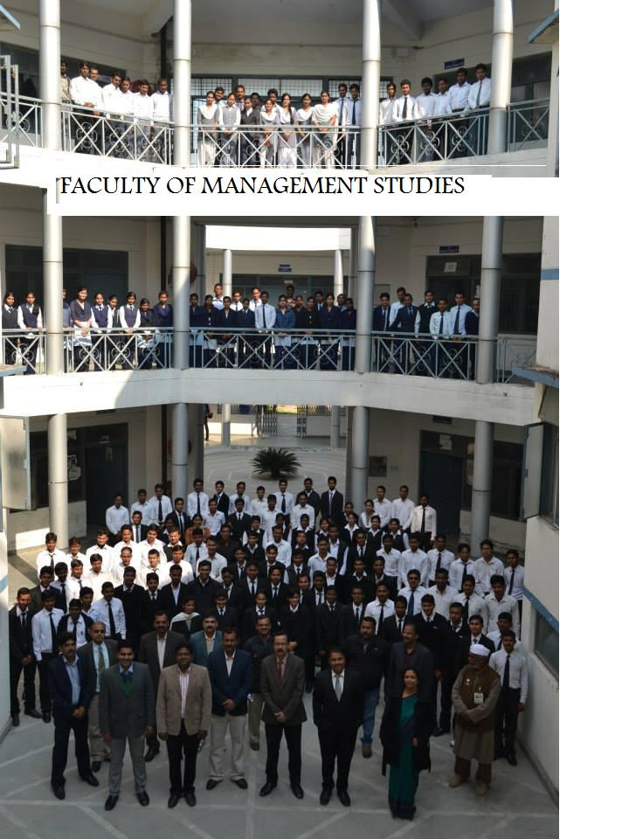
FACULTY OF MANAGEMENT STUDIES
The Faculty of Management Studies has four departments offering seven postgraduates programmes: viz., MBA, MBA (Agri-Business), MBA (E-Commerce), MBA (Business Economics), MBA (Finance and Control), MBA (HRD) and Master of Human Resource Development (MHRD). The departments are: Course
1. Department of Business Management MBA, MBA (Agri-Business), MBA (E-Commerce)
2. Department of Business Economics MBA (Business Economics)
3. Department of Financial Studies MBA (Finance and Control)
4. Department of HRD MBA (HRD) and Master of Human Resource Development (MHRD).
INFRASTRUCTURAL FACILITIES OF FMS
(A) Computer Laboratories
The Faculty of Management Studies has two well equipped computer laboratories. The system installed is core i5, 4GB Ram, 1 TB HDD, 15.6 colour monitor with multimedia and internet. There are around 100 computers and too high end servers, Laser and DeskJet printers.
(B) Library
The central library is enriched with management books and journals. The Faculty of Management Studies has also a faculty library enriched with management books and journals of national and international reputes.
(C) Conference Room
The Faculty of Management Studies is proud of having a state of the art conference/seminar room to conduct seminar/workshop/campus interviews.
(D) Meeting Hall
State of the art meeting hall to arrange meetings with Corporate/Resource persons etc.
(E) Hostel
Limited hostels seats are available inside the campus for both boys and girls. Interested students can apply for it while taking admissions.
SUPPORT FACILITIES OF THE FACULTY
(A) Scholarship
We provide almost free education to all the students who belong to the unprivileged and weaker sections of the society. We pursue and students get grants from the government for the tuition fees as per the rules and regulations of the state govt. Last year, hundred percent students (applying for scholarship) have been benefited by this scheme.
(B) Training and placement:
Since its inception the faculty has been instrumental in shaping the training and placement needs of the student and with our sincere efforts we have been able to place our students in esteemed organizations. With several professional departments coming up, a combined training and placement cell has been set up to manifold the training and placement activities.

Veer Bahadur Singh Purvanchal University, Jaunpur
FACULTY OF MANAGEMENT STUDIES
Ordinances Governing Two Year (Four Semesters)

MBA, MBA (Agri Business) MBA (E-com), MBA (Business Economics) , MBA (Finance & Control) , MBA (HRD),MHRD
Post-Graduate Degree Course

The following ordinances have been framed governing the admission, course structure, examination, research and other allied matters relating to the two year (four semester) MBA, MBA (Agri Business) , MBA (E-com), MBA (Business Economics),MBA (Finance & Control) , MBA (HRD),MHRD Post Graduate Degree Course, Veer Bahadur Singh Purvanchal University. Jaunpur.
1. ADMISSION.
  - All matters relating to admission in the MBA, MBA (Agri Business) , MBA (E-com), MBA (Business Economics),MBA (Finance & Control) , MBA (HRD),MHRD courses shall be dealt with the admission Committee constituted by the University.
  - The course is open to graduates in any discipline with a minimum of 45% marks (40% for SC/ST/OBC), from a recognized University. Those who are appearing in final examination of graduate degree may also apply for admission and shall be eligible to appear in the Admission Test but they will have to produce proof of being graduates with minimum percentage of marks at the time of admission.
  - Those who failed to secured 50% marks in undergraduate level but they have passed postgraduate examination in any discipline with at least 55% marks (50% for SC/ST/OBC) are also eligible for appearing in the admission test of the MBA, MBA (Agri Business) , MBA (E-com), MBA (Business Economics) , MBA (Finance & Control) , MBA (HRD),MHRD .
  - Admission to the MBA, MBA (Agri Business), MBA (E-com), MBA (Business Economics) , MBA (Finance & Control) , MBA (HRD),MHRD courses shall be made strictly in order of merit on the basis of the combined result of the Written Test, GD and Interview.
  - The reservation norms for admission shall be as per Govt. notification issued from time to time.
  - On the selection for admission to the MBA, MBA (Agri Business) , MBA (E-com), MBA (Business Economics) , MBA (Finance & Control) , MBA (HRD),MHRD the candidate shall deposit the fees prescribed for the purpose to get his/her admission confirmed within the time period fixed by the Admission Committee of the concerned Dept. If a candidate fails to do so, his/her offer for admission shall be automatically cancelled and the seat falling vacant shall be offered to other candidate in the merit list. There is no provision of Fee concession/exemption under any circumstances.
  - Admission in the MBA, MBA (Agri Business), MBA (E-com), MBA (Business Economics), MBA (Finance & Control) , MBA (HRD),MHRD courses cannot be claimed by any candidate as the matter of right. The Admission Committee shall have a power to refuse, reject or cancel any admission if it possesses sufficient reason to do so.

2. COURSE OF STUDY AND EXAMINATION
  - With a view to conducting the MBA, MBA (Agri Business), MBA (E-com), MBA (Business Economics), MBA (Finance & Control) , MBA (HRD),MHRD courses systematically and within a time-bound frame, the concerned Dept. Of the University shall draw up an “Academic Calendar” with the consultation of the Dean in the beginning of the academic session with the approval of the Vice-Chancellor for its implementation.
  - A candidate admitted to the MBA, MBA (Agri Business), MBA (E-com), MBA (Business Economics), MBA (Finance & Control) , MBA (HRD),MHRD course shall pursue a regular course of study in all the four semesters and attend at least 75% of the classes held to be eligible to appear in the examination however, the Dean and Vice-Chancellor for cogent reasons may condone 5% and 10% shortage in attendance respectively.
2.2.1 A candidate admitted in MBA, MBA (Agri Business) , MBA (E-com), MBA (Business Economics) , MBA (Finance & Control) , MBA (HRD),MHRD course shall taught common core paper in first semester of other MBA courses run by the university and second semester onward super specialization will be taught to the students.
3. DECLRATION OF RESULTS
3.1 The maximum and minimum marks for each theory paper, sessionals, project report and viva-
voce in the semester examination shall be as followed:
Maximum marks Minimum Percentage
Theory paper + Sessionals 75+25 (100) 36% in agg.
Theory paper + Practical 50+50 (100) 36% in agg
Summer training Report 100 36% in agg
Paper presentation/Seminar 100 36% in agg
Comprehensive Viva-Voce 100 36% in agg
Project report 100 36% in agg
The candidates who secure at least 36% of marks in each paper include aggregate of theory and sessional/practical and at least 40% of the aggregate of all papers in semester shall be declared pass in the semester examination. Therefore on the basis of the above structure the candidates result will be declared on the following manner:-
3.2.1 Pass: Those who secure 36% percent marks in each paper separately and 40% in aggregate.
3.2.2 Promoted: (Category 1): Those who secure at least 36% in at least 3 papers and 40% in
aggregate.
(Category 2): Those who secure at least 36% in all the papers but fail to secure
40% in aggregate.
3.2.3 Failed: Students who do not fall under the pass and promoted categories shall be declared as failed.
  - Students in the failed category in 1st, 2nd & 3rd semester examination shall have to re-appear in the next year in the theory papers, in which they failed. They will be allowed to continue their course as a regular student thereafter. The period of completion of the course shall be two years and can be extended for another two years in case of failed/promoted students, thus the maximum period of the course shall not be more than four years in any case.
The sessional marks of failed and promoted candidates shall, however, be carried forward as such to the next examination in which they re-appear.
  - The result of the 4th semester shall be declared on the basis of the combined marks secured by a candidate in all four Semesters of the MBA, MBA (Agri Business) , MBA (E-com), MBA (Business Economics) , MBA (Finance & Control) , MBA (HRD),MHRD courses in the following categories:
Passed 40% and above but less than 45%
2nd class 45% and above but less than 60%
1st class 60% and above but less than 75%
Distinction 75% and above
  - Those who failed in any paper of the 1st, 2nd, 3rd & 4th semester Examination shall not assigned any rank while declaring the final result.
  - In view of the fast advancement in the field of management and information technology, the course curriculum shall be revised at regular intervals.
Ph.D
Eligibility for Admission to the Ph.D: The candidates seeking for admission to the Ph.D in the concerned Department must be postgraduate in Business Economics, Mathematics, all branches of Business Administration, M.A. (Economics), M.Com. with 55% marks and the candidate has qualified the combined entrance test organized by the state Government or University.

DEPARTMENT OF BUSINESS MANAGEMENT
The Department of Business Management of the university was established in 1990 to offer two years full time programme in Business Administration. Started with the annual student intake of 30, the department has student enrolment of more than 200 with three full time MBA courses cutting across the need based functional specialization areas of management. It offers two year full time MBA, MBA (Agri-Business), MBA (E-Commerce) Programmes. In addition, the Department also offers facilities for pursuing doctoral level research (PhD) in management and allied subjects.
The continuous effort of faculty, staff, students and administration has led the Department on the path of academic excellence through a number of achievements in the department during the last few years. The department today enjoys a prominent position amongst the other management departments in state universities of comparable level. It has continuously contributed towards the creation and dissemination of knowledge in the area of business and management to the different target groups.
As it was recognized as a A+ category business school of the country in 2007 followed by its inclusion in the AICTEs list of one of the best –practices following Department in the country. The Department has been identified one among the few technical Departments of the country adopting Best and Progressive Practices (Code of conduct for students and faculty members, including professional ethics and social responsibilities) by All India Council for Technical Education (AICTE), New Delhi. The distinguished features of the department make it a potential center of excellence in holistic management education and research with focus on Indian Ethos and Human Values in Management.
OBJECTIVES
To impart need based quality management education.
To act as a catalyst in the industrial development of the region.
To identify and develop the entrepreneurial talents of this area.
To develop an ethical and human values oriented management education model based on theory, practice and self realization.
To extend the applicability of management concepts and theories in the innovative areas, relevant to the socio economic development of the country.
COURSES OFFERED
1. MBA
2. MBA (Agra Business)
3. MBA(E Commerce)
4. Doctoral Programme leading to Ph.D. degree
5. In addition, there years Bachelor of Business Administration (BBA) Programme through different affiliated institutions is also offered.

ADMISSION, SEATS, FEE STRUCTURE AND ELIGIBILITY REQUIREMENT
Annual Fees: Rs. 50,000/-(Twenty five Thousand per semester).
Eligibility: Candidates must be graduates with a minimum of 45% (40%for ST/SC/OBC) marks in graduation level. The candidates appearing in the final year of examination may also apply.
Duration: Two-year (Four semesters), Full time PG course
Mode of Admission- Through UPSEE conducted by UPTU Lucknow.
Seats: MBA-60, MBA (Agri-Business)-30, MBA (E-Commerce)-30.
COURSE STRUCTURE
(1) MBA Programme
First Semester
FMS 101: Principles of Management
FMS 102: Accounting and Financial Analysis
FMS 103: Managerial Economics
FMS 104: Research Methodology
FMS 105: Communication for Management
FMS 106: Business Environment
FMS 107: Computer Applications
Second Semester
MCC 201: Organisational Behaviour & Change
MCC 202: Business Legislation
MCC 203: Marketing Management
MCC 204: Human Resource Management
MCC 205: Production & Operations Management
MCC 206: Financial Management
MCC 207: Management of I.T. (Visual Basic, Oracle)
Third Semester
MGT 301: Entrepreneurial Development & SSI
MGT 302: Operations Research
MGT 303 (A): Consumer Behaviour & Marketing Research
MGT 303 (B): Security Analysis & Investment Management
MGT 303 (C): Management of Industrial Relation
MGT 303 (D): Purchasing & Materials Management
MGT 304 (A): International Marketing
MGT 304 (B): Corporate Taxation
MGT 304 (C): Legal Frame Work for HRM
MGT 304 (D): Production Planning & Control
MGT 305 (A): Advertising & Sales Management
MGT 305 (B): International Financial Management
MGT 305 (C): Management Training & Development
MGT 305 (D): Logistics Management
MGT 306: Case Test
MGT 307: Summer Training Report
Fourth Semester
MGT 401: Strategic Management
MGT 402: Total Quality Management & ISO
MGT 403 (A): Rural Marketing & Retail Management
MGT 403 (B): Management of Financial Institutions
MGT 403 (C): Organisational Change & Development
MGT 403 (D): Applied Operations Research
MGT 404 (A): Strategic Marketing
MGT 404 (B): Project Planning, Analysis & Management
MGT 404 (C): Management Development
MGT 404 (D): Transportation Management
MGT 405 (A): Brand Management & Services Marketing
MGT 405 (B): Foreign Exchange Management
MGT 405 (C): Counseling Skills for Managers
MGT 405 (D): Service Operation Management
MGT 406: Case Test
MGT 407: Project Work and Viva-Voce
- Papers MGT 303, MGT 304, MGT 305 & MGT 403 are for major specialization and papers MGT 404 & MGT 405 are for minor specialization.
- There shall be four specialization areas Marketing, Finance, HRM & Operations. Students are required to one major and one minor specialization by taking combination of any two of the given areas.
(2) MBA (Agri-Business) Programme
First Semester
FMS 101: Principles of Management
FMS 102: Accounting and Financial Analysis
FMS 103: Managerial Economics
FMS 104: Research Methodology
FMS 105: Communication for Management
FMS 106: Business Environment
FMS 107: Computer Applications
Second Semester
MCC 201: Organisational Behaviour & Change
MCC 202: Business Legislation
MCC 203: Marketing Management
MCC 204: Human Resource Management
MCC 205: Production & Operations Management
MCC 206: ABM 206: Financial Management and Agriculture Finance
MCC 207: ABM 207: Agriculture Economics
Third Semester
MGT 301: Entrepreneurial Development & SSI
ABM 302: Introduction to Agri-Business Management
ABM 303: Management of Floriculture & Horticulture
ABM 304: Agricultural Marketing Systems & Models
ABM 305: Farm Management
MGT 306: Case Test
MGT 307: Summer Training Report
Fourth Semester
MGT 401: Strategic Management
ABM 402: Environmental Management
ABM 403: Forestry and Fisheries Management
ABM 404: Management of Dairies & Cooperatives
ABM 405: Agricultural Export Management
MGT 406: Case Test
MGT 407: Project Work and Viva-Voce

(3) MBA (E-Commerce) Programme

First Semester
FMS 101: Principles of Management
FMS 102: Accounting and Financial Analysis
FMS 103: Managerial Economics
FMS 104: Research Methodology
FMS 105: Communication for Management
FMS 106: Business Environment
FMS 107: Computer Applications
Second Semester
MCC 201: Organisational Behaviour & Change
MCC 202: Business Legislation
MCC 203: Marketing Management
MCC 204: Human Resource Management
MCC 205: Production & Operations Management
MCC 206: Financial Management
MCC 207: Management of I.T. (Visual Basic, Oracle)
Third Semester
ECM 301: Project Management
MGT 302: Operations Research
ECM 303: Object Oriented Programming
ECM 304: Java Language & HTML
ECM 305: Web Publishing & Hosting
MGT 306: Case Test
MGT 307: Summer Training Report
Fourth Semester
MGT 401: Strategic Management
ECM 402: E-Marketing
ECM 403: Data Mining & Data Warehousing Technologies
ECM 404: E-Commerce Strategies & Models
ECM 405: Server Administration and Securities
MGT 406: Case Test
MGT 407: Project Work and Viva-Voce

Faculty  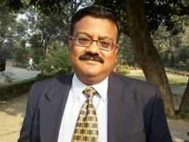 |  | 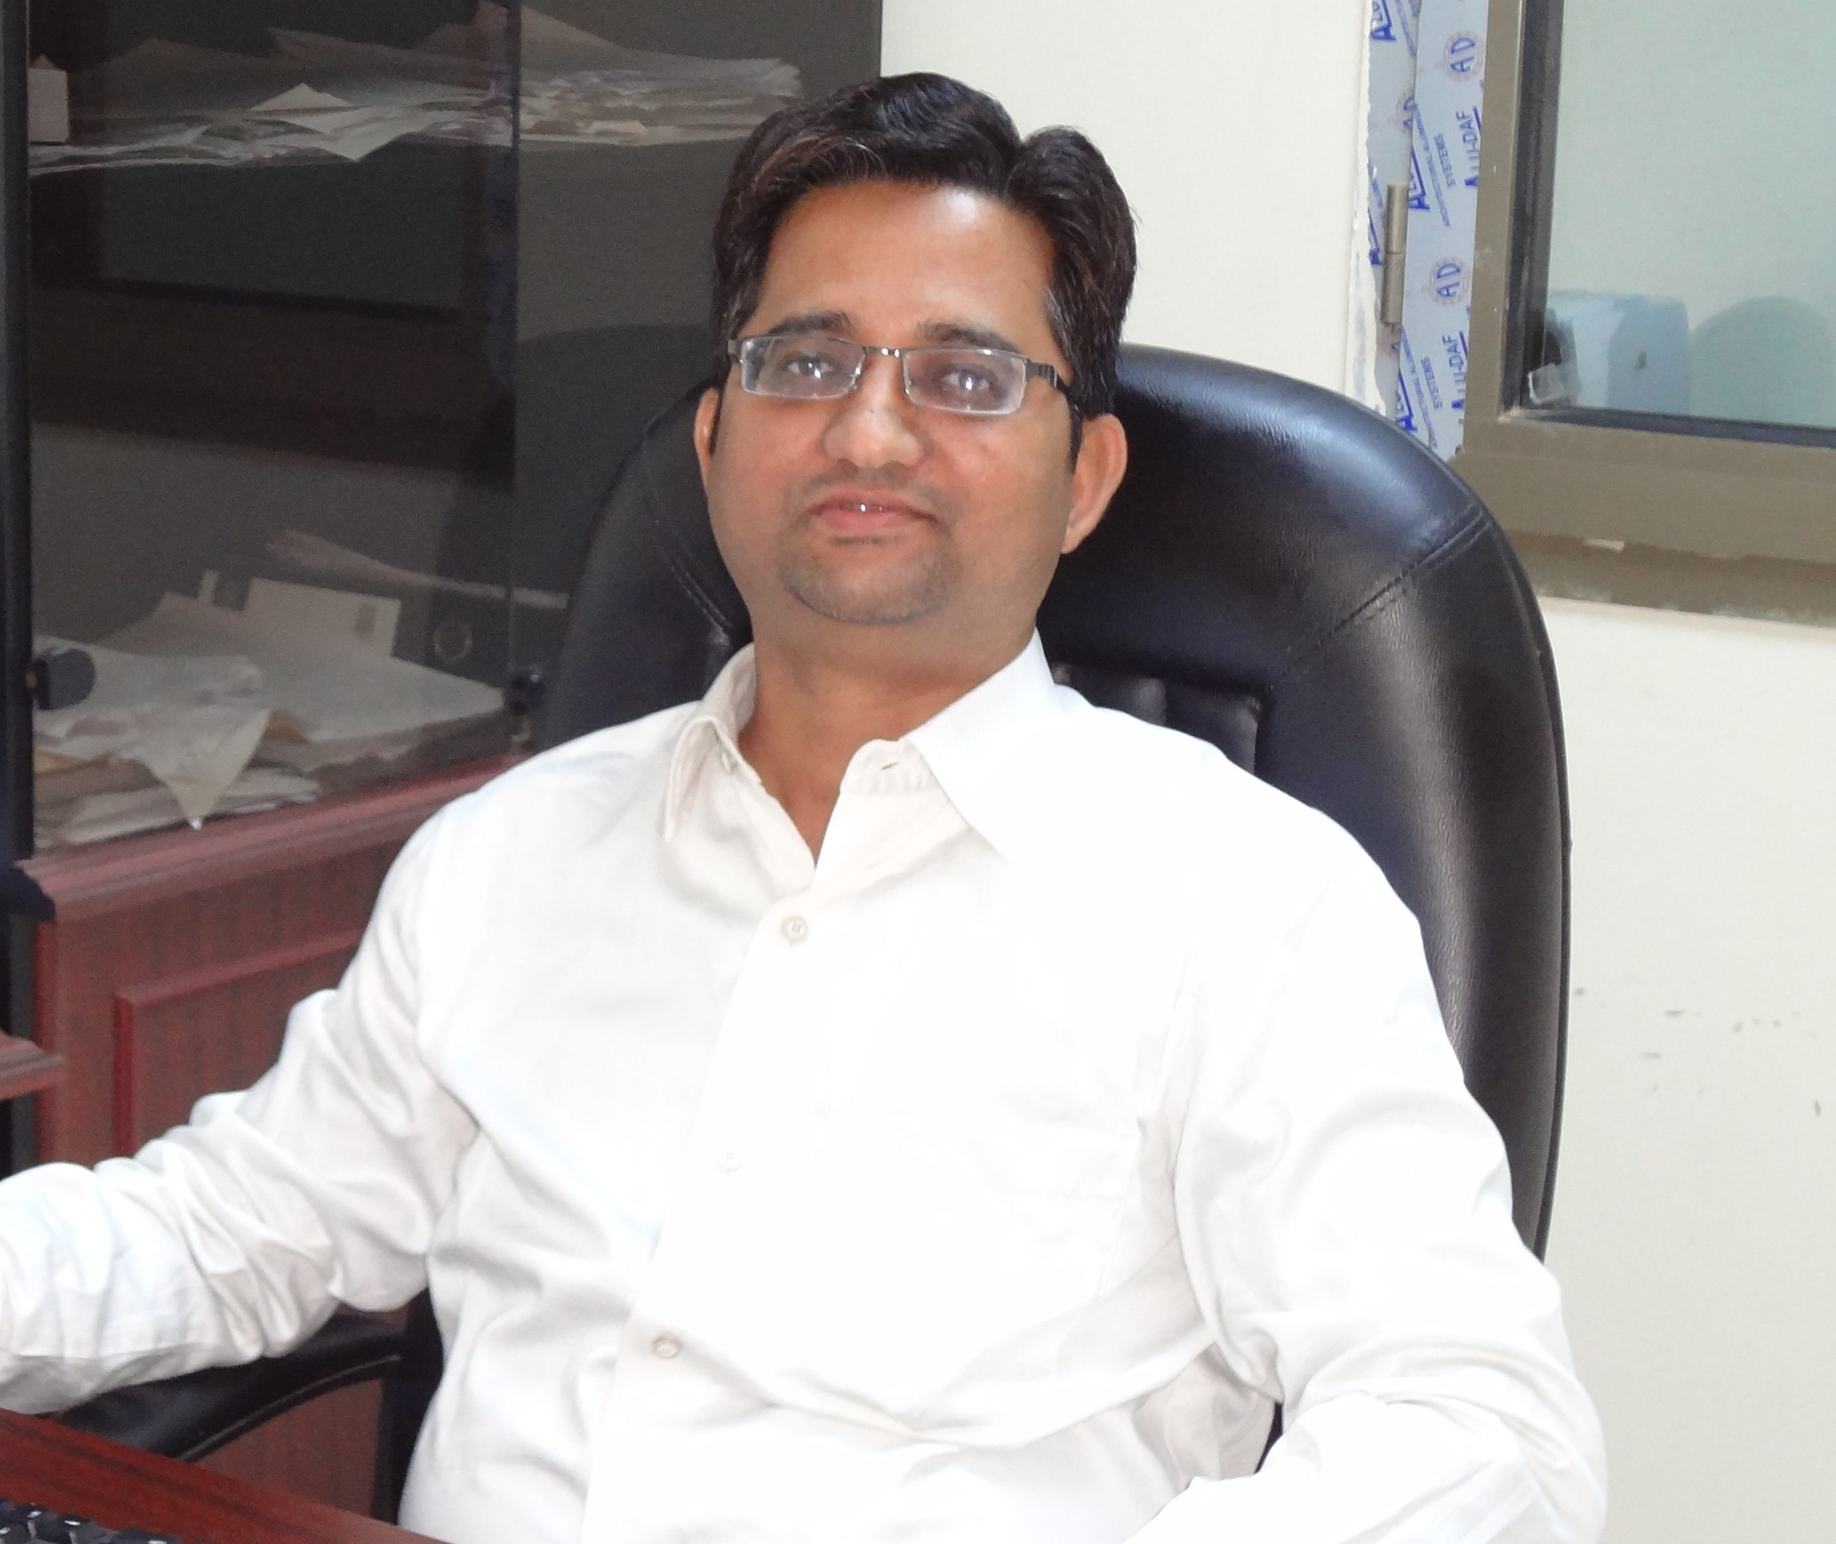
Dr. Subhojit Banerjee (On Lien)  Specialization: Marketing  Experience: 13+ Years at PG level  Email: subhojit_b@yahoo.com  Contact: 9415062368  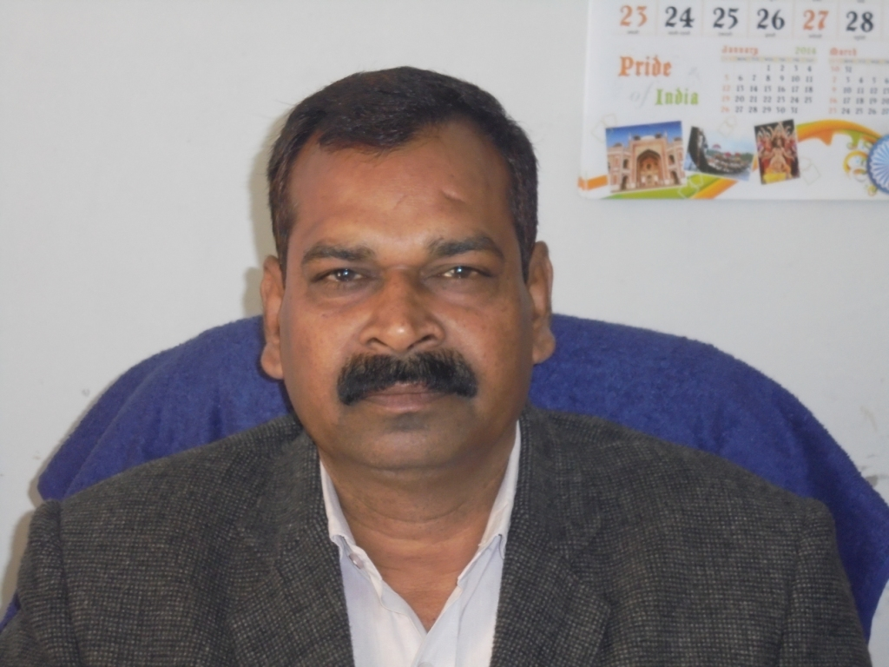 |  | Dr. Murad Ali  Specialization: Marketing,Entrepreneurship  Experience: 11+ Years at PG level  Email: alimurad@rediffmail.com  Contact: 9415980763  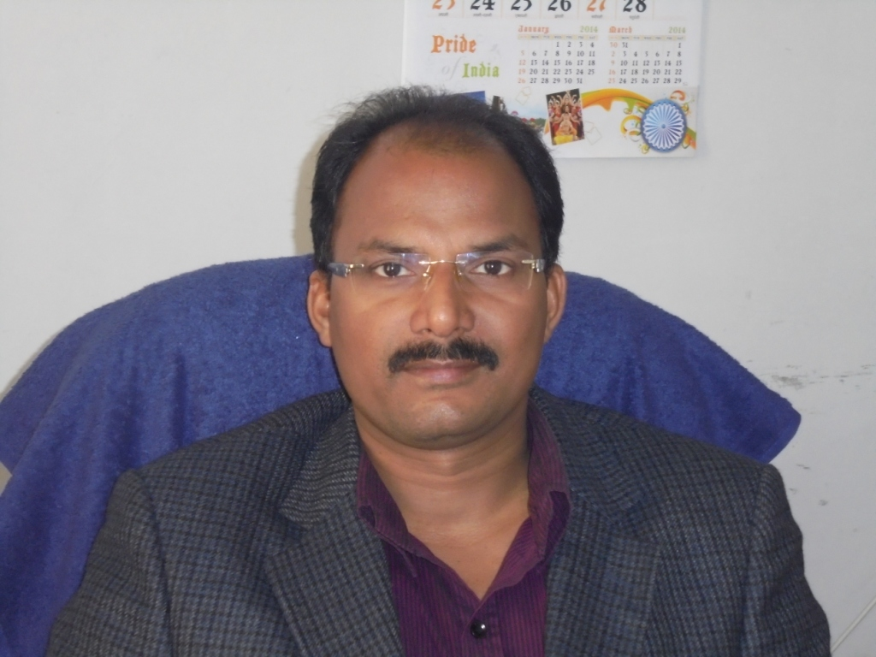
Dr. Sushil Kumar Singh  Specialization: Agri-Business Management, Marketing  Experience: 11+ Years at PG level  Email: sushilsingh.vbspu@hotmail.com  ntact: 9839041064  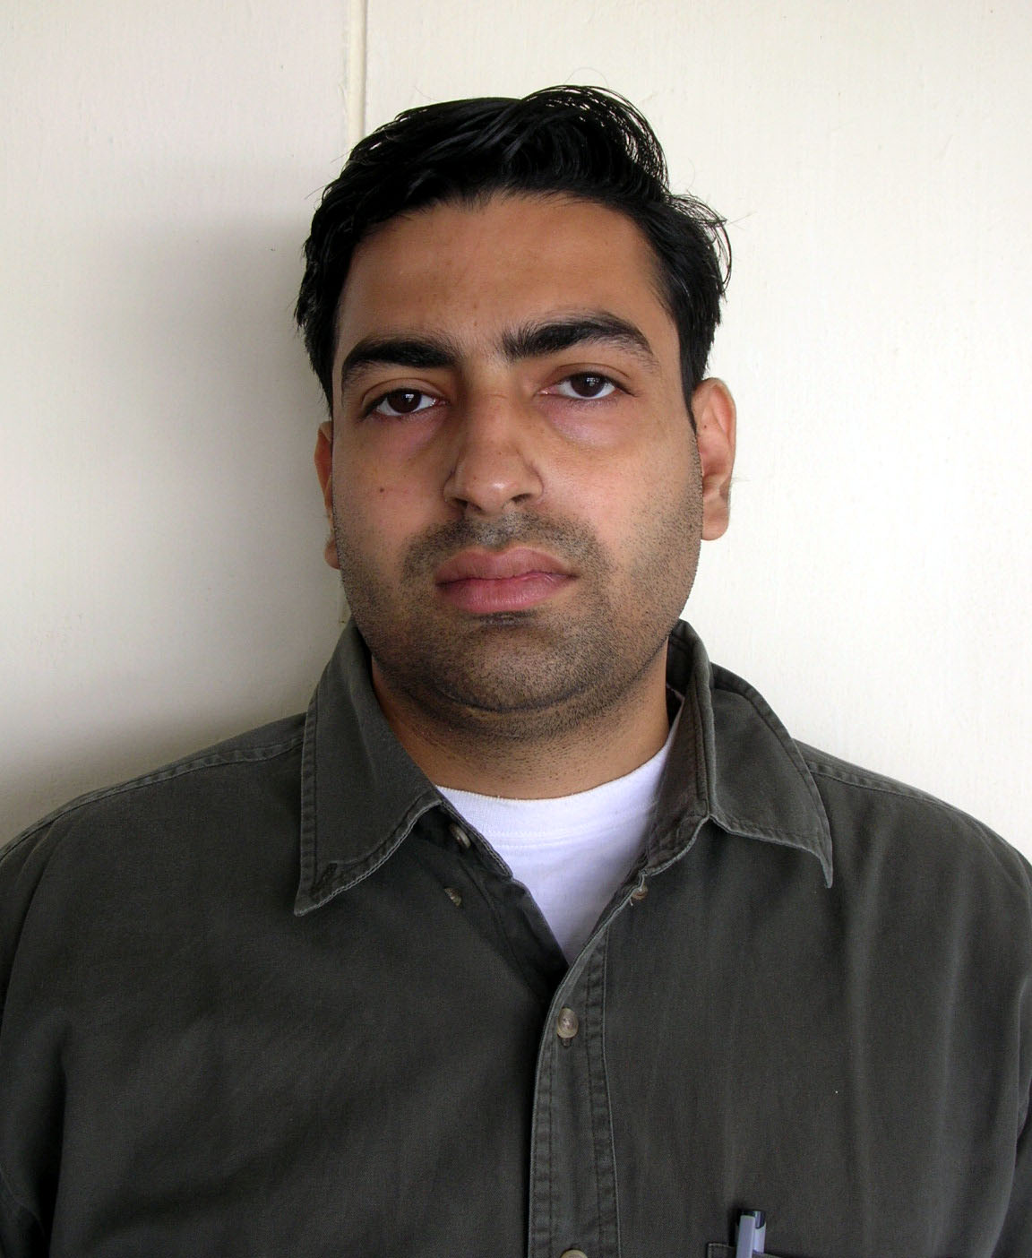 |  | Dr. Alok Singh  Specialization: Agri-Business Management, Corporate Finance  Experience: 10+ Years at PG level  Email: draloksingh@outlook.com  Contact: 9044736001  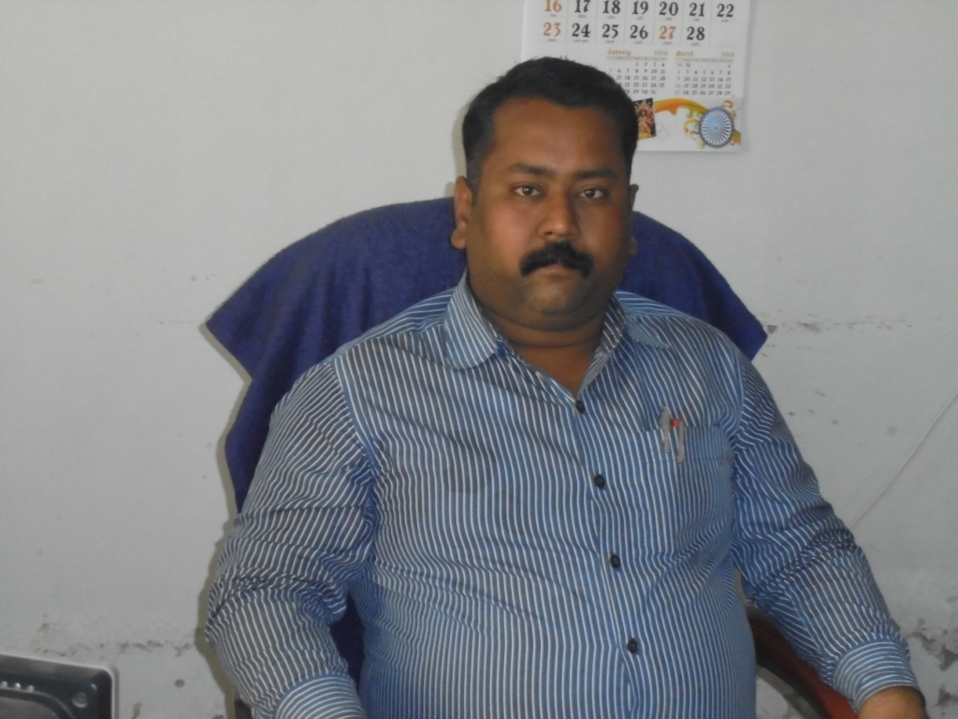
Dr. Ashish Singh  Specialization: E-Commerce, Marketing  Experience: 10+ Years at PG level  Email: ashishsinghvatsa@yahoo.co.in  Contact: 9450018000  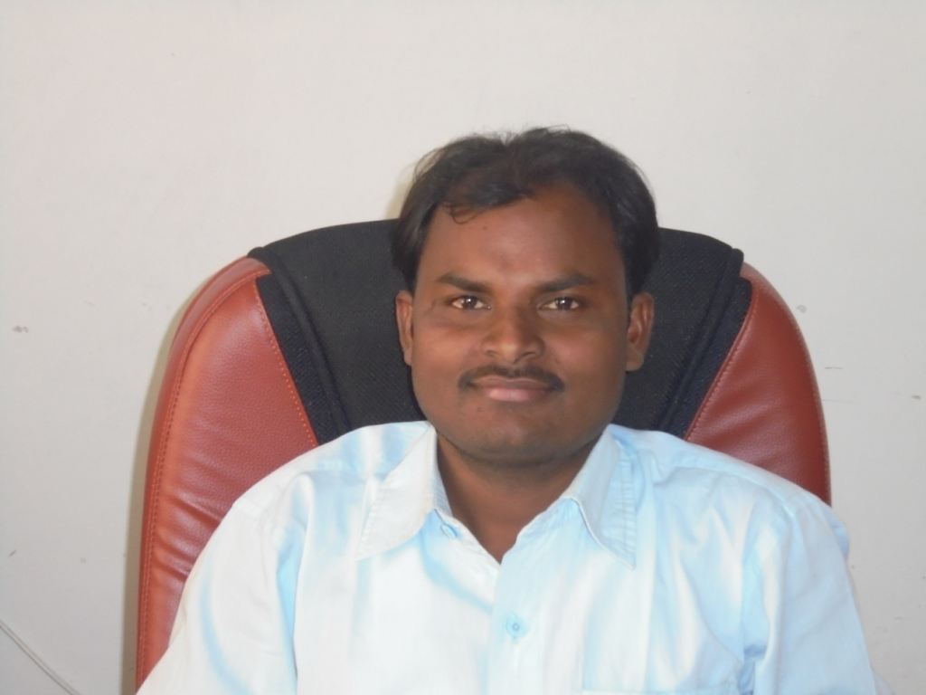 |  | Mr. Pramendra V. Singh  Specialization: Marketing  Experience: 4+ Years at PG level  Email: pvsingh.vbspu@hotmail.com  Contact: 9451165567  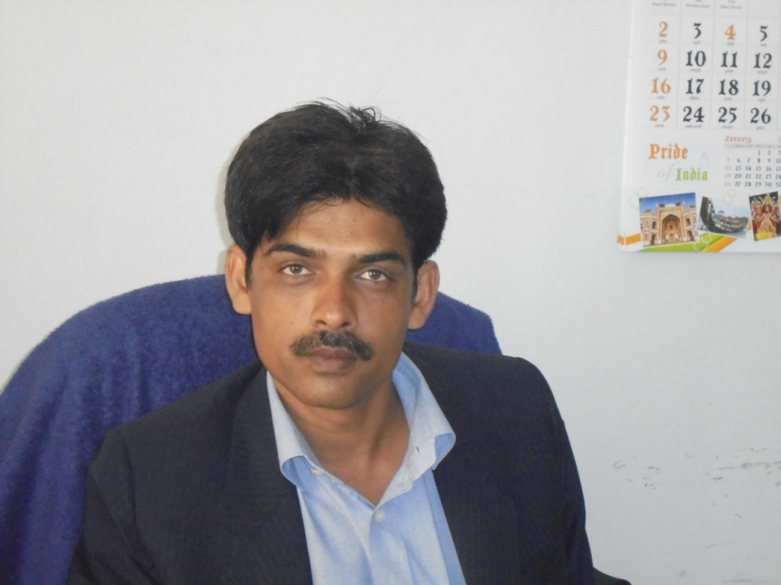
Mr. Rajesh kumar  Specialization: HRM  Experience: 3+ Years at PG level  Email: rajeshsiddharth334@gmail.com  Contact: 7379777848  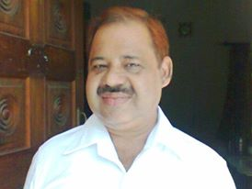  Mr. Amit Singh Vats  Qualification: B.Tech.  Specialization: Computer ProgrammingEmail:amitvats_pu@yahoo.co.in |  | Mr. Anshuman  Specialization: Marketing  Experience: 5+ Years at PG level  Email:anshu.gzp@rediffmail.com  Contact: 8115944227

DEPARTMENT OF BUSINESS ECONOMICS
The Department of Business Economics started in the year 1998 with the approval of the State Government. Since its inception thirteen batches have passed out so far and the students are placed all around the country and abroad. The Department always aims to focus on the economics perspectives of the business and the application of the economics and statistics in the area of Marketing Finance, HR, Logistics and International Business Management. Economics being the mother of all the commerce and management disciplines helps to develop new insights leading to inculcate analytical skills and knowledge amongst the students. The Department was established with a view to design and impart management course which focuses on the business and its economical implications with respect to the cost, pricing, strategy, HR etc to attain maximum economical value. The MBA (Business Economics) course is an innovative blend of economics, commerce, statistics and management which gives an edge to effective decision making and enables students to develop analytical and entrepreneurial skills. It also provides a platform to explore innovation, creativity and professionalism to the upcoming management aspirants. The present area of globalization and liberalization witnessed a revolutionary change in the domestic as well as in the global economics scenario. The Department always updates its curriculum with the upcoming trends in global industry and academics. The Business Economics Department has been an innovative force in research and teaching; The current research interests of the Department Faculty include Business Policy and Strategy, International Business, Macro Economic/Policy, International Finance, Marketing, Consumer Behavior, Labor Economics and Economics of Climate Change. Green Marketing, Retail Management, Entrepreneurship Development etc.
The Department arranges summer training in the second semester and the final placement of students in industrial and commercial houses and reputed research organizations.

Mission
The department has consistently endeavored to provide students with strong conceptual and analytical skills, in order to inculcate proficient managerial capabilities in them. So that they are in a position to evaluate the efficacy of various tools applied in different functional areas of management in regard to their contribution to the economy. The academic pedagogy is such, as to create an environment where learning is facilitated and chances for self expressions and introspection are plentiful.

Objectives
- To evaluate the efficacy of various managerial tools applied in different functional areas of management in regard to their contribution to the economy.
- To produce Business experts and Business analyst who can assess business activity accurately and may play a vital role in decision-making process of a firm.
COURSES OFFERED
- MBA (Business Economics) with dual specialisation in Marketing, HR, Finance, International Business, Logistics and Quantitative Techniques.
- Ph.D

Admission Details
- Annual Fees: Rs. 50,000/-(Twenty five Thousand per semester).
- Eligibility: Candidates must be graduates with a minimum of 45% (40%for ST/SC/OBC) marks in graduation level. The candidates appearing in the final year of examination may also apply.
- Duration: Two-year (Four semesters), Full time PG course
- Mode of Admission: Through UPSEE conducted by UPTU Lucknow
- Seats:60
COURSE STRUCTURE

SEMESTER I
- FMS--101. Principles of Management
- FMS --102. Communication for Manager
- FMS --103. Accounting and Financial Analysis
- FMS --104. Managerial Economics
- FMS --105. Research Methodology
- FMS --106. Business Environment
- FMS --107. Computer Application
SEMESTER II
- BE --201. Industrial Economics and Law
- BE --202. Organization Behaviour
- BE --203. Corporate Finance
- BE --204. Marketing Management
- BE --205. Management and Cost Accounting
- BE --206. Business Law
- BE --207. Summer Training Report Presentation and
Viva-Voce
SEMESTER-III
Compulsory Papers
- BE --301. Project Appraisal and Investment Planning
- BE --302. Operation Research and Decision Methods
- BE—303. Rural Management and Entrepreneurship Development
- Specialization (Student can select any two of the following Groups)
Group (A) Quantitative Techniques in Business
Economics
- BE - (I) Advanced Operations Research
- BE - (II) Mathematics for Management Research
Group (B) International Business Management
- BE – International Business Strategy
- BE - International Economics & Trade Policy
Group (C) Logistic management
- BE - (I) Production & Operations Management
- BE -II) Enterprise resource planning (ERP)
Group (D) Marketing
- BE - (I) Integrated Marketing Communication
- BE - (II) Consumer Behaviour
Group (E) Finance
- BE - (I) Derivatives and Risk Management
- BE - (II) International Finance
Group (F) Human Resource Management
- BE - (I) Organizational Development and Change
- BE - (II) Conflict Management & Negotiations
SEMESTER IV
Compulsory Paper:
- BE- 401. Business Policy & Strategy

Elective Papers: (Student can opt any two of the following specialization Groups)
Group (A) Quantitative Techniques in Business
Economics
- BE - (I) Econometric Methods
- BE - (II) Business Forecasting
Group (B) International Business Management
- BE – (I) Export Import Documentation
- BE - (II) International HRM & Cross Culture
Group (C) Logistic management
- BE - (I) Economics of supply chain
- BE - (II) Indian Transport System
Group (D) Marketing
- BE - (I) Marketing of Services
- BE - (II) International Marketing
Group (E) Finance
- BE - (I) Security Analysis and Portfolio
    - Management
- BE - (II) Financial Services
Group (F) Human Resource Management
- BE - (I) Labour Law and Industrial Relation
- BE - (II) Human Resource Development
BE - 407. Dissertation
BE - 407. Comprehensive Viva-Voce.

Specific Achievement of the Department

The department has been the nodal centre for Agriculture Entrepreneurship of the Jaunpur district and regular workshops for the farmers regarding professionalism of agriculture professional have been organized.

Sponsored projects

The Department of Business Economics has completed two major research projects sponsored by the UGC.

Research activities

The faculty members of the department are involved in several research activities. Seven students have been awarded Ph. D. Degree from the department. Dr., Manas Pandey has been conferred with the Fellow of Indian Commerce Association in the year 2009 and has been awarded Best Business Academy Award for best research paper in 2008. He participated in World Finance Conference at Portugal and Greece twice. Dr. H C Purohit has been conferred Professor Manu Bhai Shah Memorial Research Award for his Research paper in 2011.

Events organized (seminar/workshop etc)

The Department has organized three seminars sponsored by ICSSR.

Industry Interface
The concept of Industrial visits has been woven into the academic practices of the department keeping in mind that experiential learning is the essence of management teaching. The motive is to provide the students with a right blend of theoretical learning and an opportunity to witness how those concepts are utilized in the practical environment. In pursuit to the above the students of the Department have visited Darjiling, Sikkim, Bhutan, Dehradun, Haridwar, Rishikesh, Nagpur, Nasik and Mumbai etc.

Extra-curricular & Co-curricular activities

The students are participate in the inter-departmental/faculty cultural/sports competitions organized by the University. Seminar presentation, business quiz, and management games are the regular activities of the students in the department.

Core Faculty

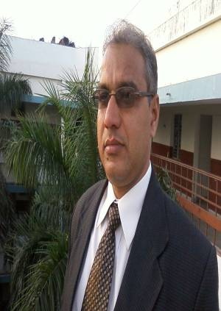
Dr Manas Pandey Dr. H. C. Purohit
Specialisation: Finance Specialisation: Marketing
Area of Interest: Security Analysis and Portfolio Management, Area of Interest: Marketing Research, Strategic Management
Management Accounting, Consumer Behaviour
Experience: 20 years at PG level Experience: 17 years at PG level
Email: manas_pandey@rediffmail.com Email: hcpurohit_mbe @rediffmail.com
Mobile: 9415207029 Mobile: 9415207263

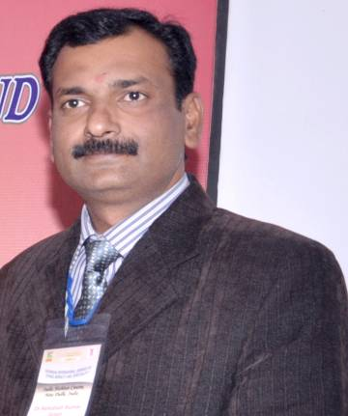
Dr. V. D. Sharma
Specialisation: Labour Economics & Industrial Relations Dr. Ashutosh Kr Singh
Area of Interest: Labour Economics Specialisation: Marketing
Experience: 15 years at PG level Area of Interest: Quantitative Methods,
Email :drvd_sharma@yahoo.co.in International Marketing
Mobile: 9450873419 Experience: 14 years at PG level
Email: singhashu_pu@sify.com
Mobile: 9451465844

Activities in the Department
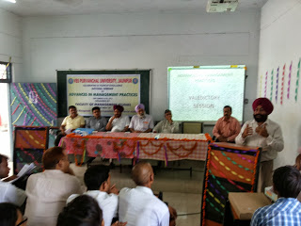
National Seminar on Recent Trends in Management Practices: Key Speakers are Prof Ran Singh, Prof Gurcharan Singh Prof Manjeet Singh(Punjab University Patiala),Prof K M Sharma(MONIRBA,Alld University), Prof Manoj Pathwardhan IIITM Gwalior, Prof H P Mathur,FMS BHU Varanasi,Prof S Rangnekar from IIT Roorkee.
M

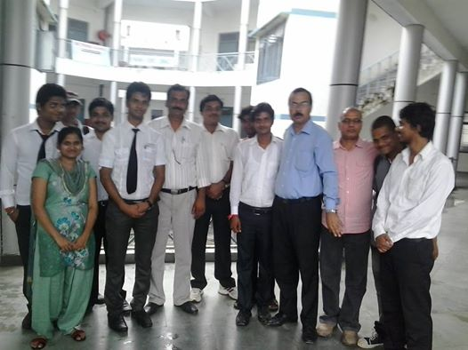
Department students with the Dean FMS Dr MAnas Pandey,DR H C Purohit and Dr Ashutsoh Kr Singh

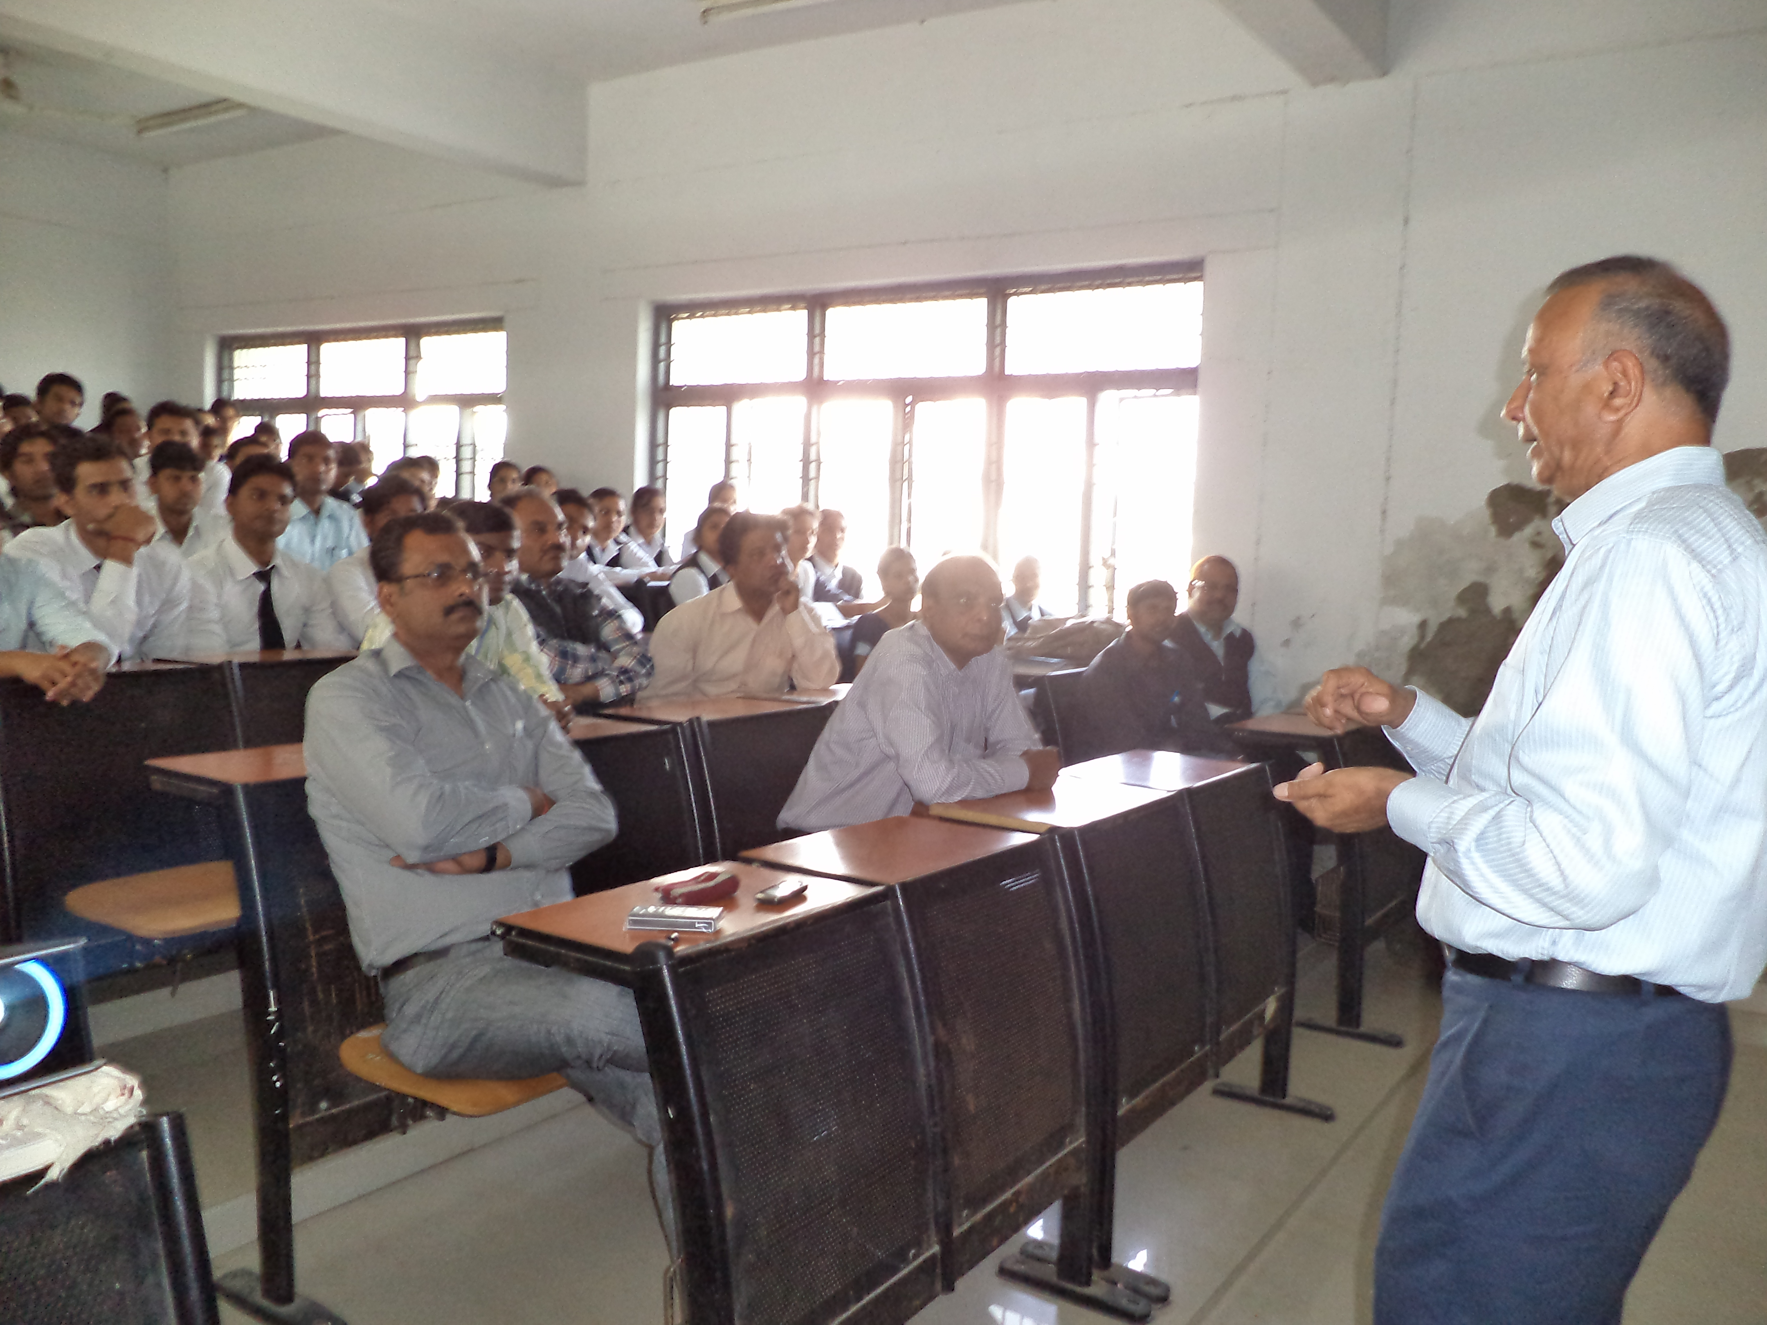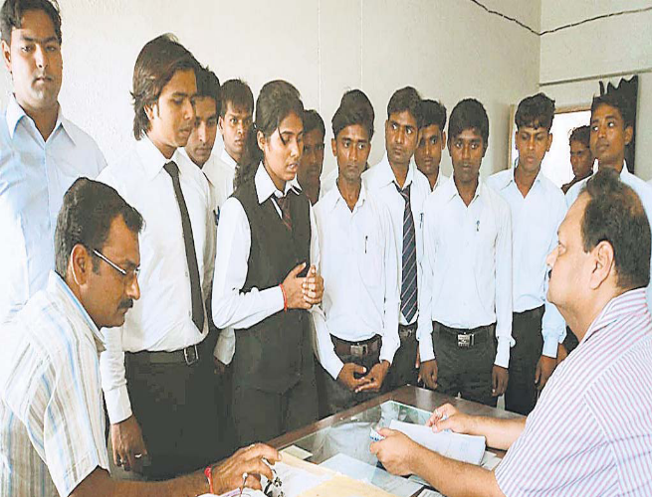
Prof S P Singh,FNA,Former VC,HNB Garhwal Central University delivering Lecture on Environment and its Impact on Economic Growth
Prof KK Agrawal ,Dean,FMS,Kashi Vidyapeeth during an Interview with the students of MBA(Business Economics)

DEPARTMENT OF FINANCIAL STUDIES
The Department of Financial Studies was established in the year 1999 to keep pace with the requirements of educational up-gradation and challenges faced by the finance professionals of corporate sector. The course curriculum of MBA (Finance & Control) programme has been designed in consultation with eminent professionals from the industry, academics and government. It is regularly updated on the needs of industry.
The Department arranges summer training in the second semester and the final placement of students in industrial and commercial houses and reputed research organizations.Reaching new heights of academic excellence and setting a new parameter of performance in teaching, learning and evaluation, research, consultancy and extension, infrastructure and learning resources, students support and progression, organization and management and healthy practices. Apart from the class teaching, our pedagogy includes case study, presentations, problem solving and brain storming teaching methodology. The Department is mandated to produce skilled finance and management professionals, consultants and academicians equipped with knowledge and practical training to suit the requirements of the corporate and academic world.
COURSES OFFERED:
- MBA (Finance & Control)
- Ph.D
Admission Details

- Annual Fees: Rs. 50,000/-(Twenty five Thousand per semester).
- Eligibility: Candidates must be graduates with a minimum of 45% (40%for ST/SC/OBC) marks in graduation level. The candidates appearing in the final year of examination may also apply.
- Duration: Two-year (Four semesters), Full time PG course
- Mode of Admission- Through UPSEE conducted by UPTU Lucknow

COURSE STRUCTURE
SEMESTER-I
FMS --101. Principles of Management
FMS --102. Accounting and Financial Analysis
FMS --103. Managerial Economics
FMS --104. Research Methodology
FMS--105. Communication for Management
FMS--106. Business Environment
FMS --107. Computer Application
SEMESTER-II
FC --201. Managerial Finance
FC --202. Managerial Accounting
FC --203. Organization Behaviour
FC --204. Quantitative Techniques for Management
FC --205. Legal Aspects for Finance Managers
FC --206. Business Policy for Managers
FC --207. Viva-voce
SEMESTER-III
FC --301. Financial Statement Analysis
FC --302. Indian Finacial System
FC --303. Financial Derivatives and Risk Management
FC --304. Marketing of Financial Services
FC --305. Investment Management
FC --306. Entrepreneurship and Small Business Management
FC --307. Summer Training, Presentation and Viva-voce
SEMESTER-IV
FC –401. Corporate Restructuring
FC –402. Business Valuation
FC –403. Financial Modeling for Managers
FC –404. Project Management and Finance
FC –405. Multinational Financial Management
FC –406. One Elective (To be chosen from the given list)
FC –407. Project Report and Viva-voce & presentation
Specialization
(Student can select any one of the following papers)
1. Management of Financial Institution and Services
2. Commercial Bank Management
3. Merchant Banking
4. Venture Capital and Private Equity
5. Micro Finance
6. Real Estate Investment Management
7. Treasury Management
8. Direct and Indirect Tax Planning
9. Fixed Income Securities
10. International Financial Reporting and Analysis
11. Behavioural Finance



Core Faculty

Dr. S.K. Sinha Dr. Ajay Dwivedi
Associate Professor Associate Professor
Specialization: Accounting and Finance Specialization: Accounting and Finance
Area of Interest: Security Analysis & Portfolio Mgmt Area of Interest: Indian Financial System, Research Methodology
Mobile:941527195 Mobile:8808231000
Email:drsksinhapu@gmail.com Email:ajaydwivedip@gmail.com
 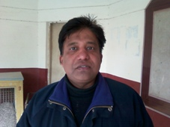 Mr. Alok
Mr. Sachin Agrawal Mr. Alok Gupta
Assistant Professor
Assistant Professor (Senior) Specilization: Quantitative technique,
Specialization: Corporate tax, Capital market Organizational behaviour
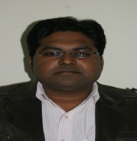

Mr. Sushil Kumar
Assistant Professor
Specialization: Accounting and Finance
Area of Interest: Business & Corporate Laws, Corporate Restructuring
Mobile:9451870747
Email:sushilkmr25@gmail.com

Dr. H. C. Purohit
Specialisation: Marketing Dr. Ashutosh Kr Singh
Area of Interest: Marketing Rsearch,Strategic Management, Consumer Behaviour Specialisation: Marketing
Experience: 17 years at PG level Experience: 14 years at PG level
Email: hcpurohit_mbe @rediffmail.com Area of Interest: Quantitative,,International
Mobile: 9415207263, Email: singhashu_pu@sify.com
Mobile:9451465844

Marketing, Research Methodology
Experience: 14 years at PG level E-mail: singhashu_pu at sify.com
Mobile: 9415207263, Mobile: 919451465844

DEPARTMENT OF HRD
The Department of HRD under Faculty of Management Studies was established in the year 1999 with the objective of providing education and training to students of this region in the art of managing human resource. It aims at imparting knowledge and professional skills to meet the demands of the changing business environment in the post liberalized economy, through strengthening linkages of business strategy to HR Strategies, Policies & Systems for sustainable development of any organization. The students are well placed in Public Sector Undertakings, Corporate Houses and Consultancy Organizations, performing the core activities of HR in managerial positions

Academic philosophy of the department
To be center of excellence by equipping the students with the tools & techniques essential as a strategic contribution of HRD to organizational success for sustained competitive advantage.
Objective
- The main objective of this course is to provide the industry with highly trained and motivated HR professionals capable of maintaining and developing the new knowledge workers. More specifically, the course aims at:
- To equip the students with requisite skill in human resource planning and control;
- To familiarize the students with latest HR processes in the industry;
- To provide the students an insight into the understanding of the value of human capital and its effective utilization
- To inculcate in the students an urge for continuous learning, a moral value system and a spirit for commitment to their job.

COURSES OFFERED:
MBA (HRD)
Program Duration: Two years regular
Seats: 60
Annual Fees : Rs.50000 (RsTwenty Five Thousand per semester)
Admission Procedure: Through UPSEE, UPTU,Lucknow
Eligibility: Graduate in any discipline with a minimum of 45% (5% Relaxation for SC/ST) marks.
MHRD
Program Duration: Two years regular
Seats: 30
Annual Fees: Rs.30,000 (Fifteen thousand per semester)
Admission Procedure: Through Purvanchal University Combined Admission Test (PUCAT) conducted by University.
Eligibility: Graduate in any discipline with 45% marks (5% relaxation for SC/ST and Physically challenged candidate)

COURSE STRUCTURE
MBA (HRD)
Semester-I
FMS-101. Principles of Management
FMS --102. Accounting and Financial Analysis
FMS --103. Managerial Economics
FMS --104. Research Methodology
FMS--105. Communication for Management
FMS-106. Business environment
FMS-107. Computer Applications
Semester-II
MHR-201. Personnel Management
MHR.202. Human Resource Development
MHR.203. Industrial Relations
MHR. 204. Industrial Psychology
MHR. 205. Labour Welfare & Industrial Discipline
MHR-206. Labour Law
MHR-207. Organizational Behaviour
Semester-III
MHR-301. Training & Development
MHR-302. Managing organizational Conflict & Stress
MHR-303. Career and Performance Management
MHR-304. Strategic Human Resource Development
MHR-305. Human Resource Accounting
MHR-306. Ethical Issues in Management
MHR-307. Summer Training Project & Viva-voce
Semester-IV
MHR.401.Leadership & Group Dynamics
MHR-402. TQM & ISO-9000
MHR-403. Consultancy & International HRM
MHR-404. Organizational Change & Development
MHR-405.Social Security and Compensation Laws
MHR-406. Emerging issues in HRM
MHR-407. Dissertation report & Viva-voce

MHRD
Semester-I
FMS-101. Principles of Management
FMS --102. Accounting and Financial Analysis
FMS --103. Managerial Economics
FMS --104. Research Methodology
FMS--105. Communication for Managers
FMS-106. Business environment
FMS-107. Computer Applications
Semester-II
MHR-201. Personnel Management
MHR.202. Human Resource Development
MHR.203. Industrial Relations
MHR. 204. Industrial Psychology
MHR. 205. Labour Welfare & Industrial Discipline
MHR-206. Labour Law
MHR-307. Organizational Behaviour
Semester-III
MHR-301. Training & Development
MHR-302. Managing Conflict & Stress
MHR-303. Career and Performance Management
MHR-304. Strategic Human Resource Development
MHR-305. Human Resource Accounting
MHR-306. Ethical Issues in Management
MHR-207. Summer Training Project & Viva-voce
Semester-IV
MHR.401.Leadership & Group dynamics
MHR-402. TQM & ISO-9000
MHR-403. Consultancy & International HRM
MHR-404. Organizational Change & Development
MHR-405. Indian Laws for Compensation and Wages
MHR-406. Emerging issues in HRM
MHR-407. Dissertation report & Viva-voce

Specific Achievement of the Department
- Kamla Award, 2009 for best paper published, entitled as ‘Competency of Executives in BPO’ in Indian Journal of Training and Development [IJTD] vol. XXIX, January-March 2009, ISTD, New Delhi.
- Won Second Best Paper Award in Paper presented entitled as ‘Career commitment, Career Satisfaction: Role of Ethics and Affective Commitment’ in XIII annual International seminar on ‘Ethics, Morality & Spirituality’ organized by Delhi School of professional studies and research (DSPSR), Delhi held on 4-5 January, 2012 .
- Best Paperaward for the research paper title “Transformational leadership as predictor of conflict handling strategy: An empirical study in Indian IT Companies”, published in the Indian Journal of Training and Development (IJTD), Vol. XXXXII, April-June 2012 issue (ISTD is a body of International Federation of Training and Development Organizations (IFTDO), USA and Asian Regional Training and Development Organizations (ARTDO), Manila).

Sponsored projects

- UGC, New Delhi funded project on “Dynamics of organizational commitment, culture, employee involvement with employee attrition in BPO Industries”.
- UGC, New Delhi funded project on “Influence of Perceived Organizational Support, Job Interdependence and Empowerment at work on the job behavior of employees and organizational Performance drivers”.
- Department of Labour, Government of UP funded “National Child Labour Project”.
- ICSSR, New Delhi funded project on “Influence of employer branding, employee engagement and leadership style on entry-level employees’ retention in Indian IT sector”.

Events organized (seminar/workshop etc)

Visiting faculty from premier educational institutions and senior practicing managers from reputed business organization are invited to provide knowledge about latest trends in industry there by enriching the students regarding the changes and happenings in business world.

Special Lecture and Workshop (Last one year)

- A special lecture was organized by HRD department in March-2013. Mr. Parmanand Singh, Rtd. Sr. VP-HR, Aditya Birla Groups was shared his view on Relevance of Trade Unionism with special reference of Aditya Birla Groups.
- Students participated in a workshop on Communication skills & Personality Development. Dr. M. Patwardhan, IIITM, Gwalior shared his views on communication skills & ideas on C.V preparation and different aspects of personality in March- 2013.
- Prof. H.K. Singh, BHU visited the department and shared his views on different aspects of Management in Feb-2013
- Prof. Alok Rai, FMS BHU also visited the department and shared his views on marketing aspects and its relevance with H.R.
- Dr. Ajay Wagh, Head of Department, IGNTOU, Amarkanta interacted with the students with the students of HRD session 2012-14 & 2011-13 and shared their views on Change Management.
- Students participated in International workshop Multi- Variant Analysis Techniques in October- 2013.
- Students participated in a workshop on the Corporate Social responsibility Mr. Sunil Tyagi, GM, Union Bank of India, Jaunpur.
- A special lecture on Corporate Social Responsibility was also organized by HRD Deptt. Mr. Manish Kumar Singh, GMR Group has shared his view on corporate social responsibility.

Industry Interface

To get practical exposure with conceptual knowledge of management is very much important for HR Professional so that they may understand how they can use or apply conceptual knowledge to several problems of real world. For this purpose Department and University plans to visit several organizations, like-

- IFFCO, Phulpur Allahabad
- Suarbhi Shodh Sansthan, Dagmagpur, Chunar, Mirzapur
- PEPSICO Plant, Satharia, Allahabad

Extracurricular & Co-curricular activities

The department strongly believes in holistic development of its students. For this it indulges in different activities such as cultural programs, Wall-magazine, Presentations, Debate, etc.

Achievements/ Activities by Students
- Ms. Roma Srivastava won 1st prize on Women Empowerment Debate organized by Rotary Club.
- Students of MHRD & MBA (HRD) won several prizes in the cultural fest of the University Jhankar- 2013. They won-
First prize- Play (Tabeez- A True Story)
Second prize- Mehandi competition
Second prize- Rangoli competition
Innovative Practices:

- Wall magazine is prepared by the students of HRD department on contemporary issues in Human Resource Development.
- Students organized quiz competition based on the Wall magazine issues.
- Business News is regularly displayed on the board and a discussion on the “Business Environment and Strategic Role of HR” is conducted in every fifteen days on the issues displayed during the period.

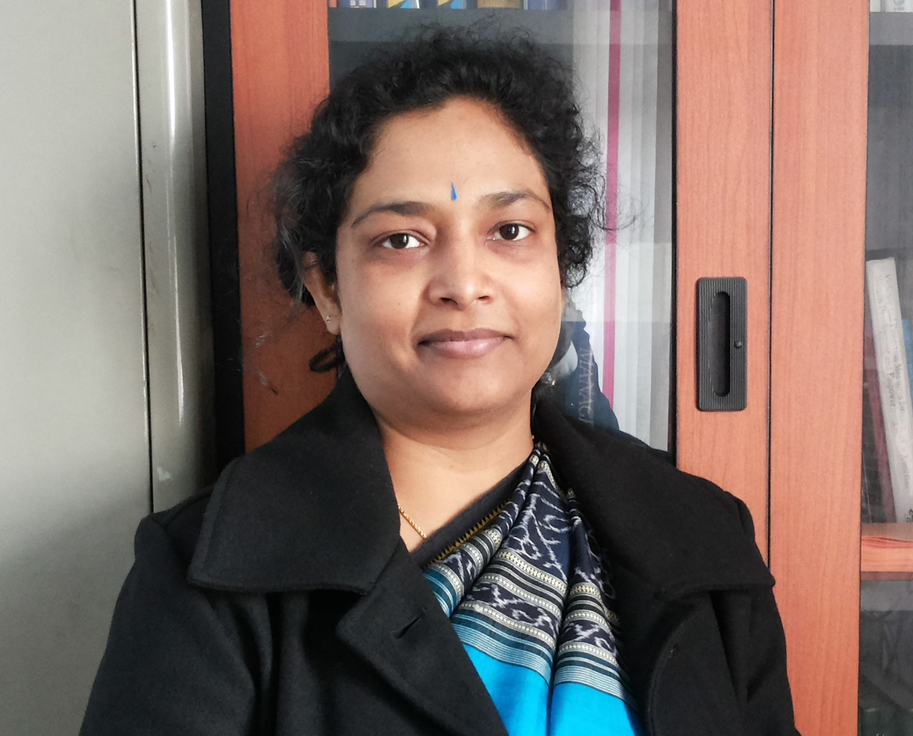

Core Faculty

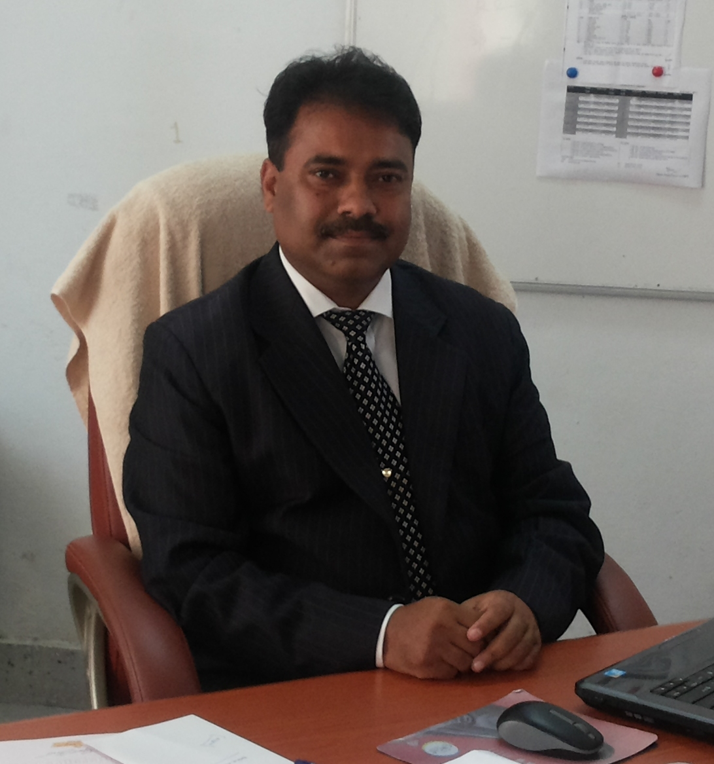
Dr. Avinash D. Pathardikar Dr. Sangeeta Sahu
Qualifications: Ph.D (HRD), MPM & IR, LLB, UGC-NET Qualification: Ph.D, M.Phil, MPM & IR, UGC-NET [JRF], FDP-IIM, Ahemedabad
Specialisation: HRM and OB Specialisation: Human Resource Development, Organization Behaviour
Area of Interest: Commitment, Culture, Leadership, Attrition Area of Interest: Competency Management, Organizational Culture, Commitment
Experience: 14 years at PG level Organizational Attachment, Employer Branding and Career Management.
Email: avinashphrd @gmail.com Experience: 13 years at PG level
Mobile: 9450873419 Email: sangeeta_hrd@yahoo com
Mobile: +91-9415234032
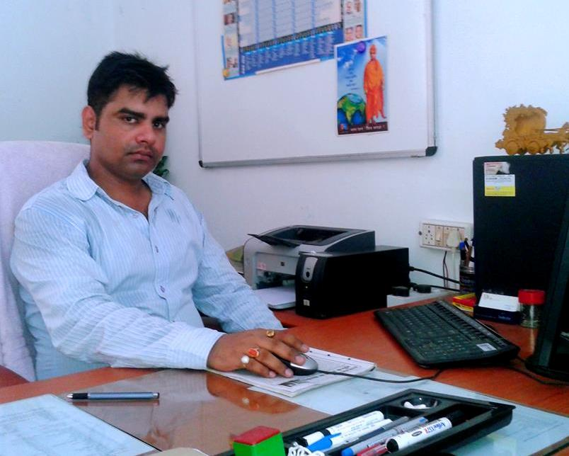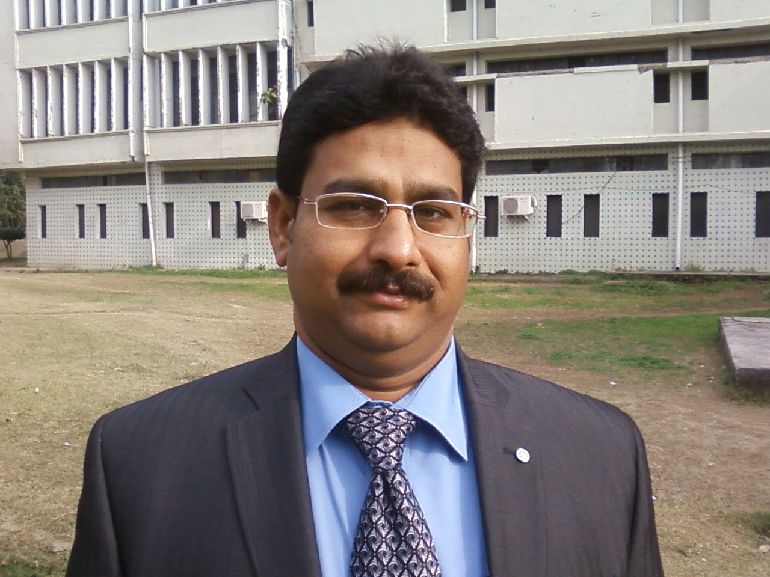
Dr. Rashikesh
Qualifications: Ph.D, MBA, M.Com. [Gold Medalist], UGC-NET Dr. Ajay Wagh (On Lien)
Specialisation: HRM Qualifications: Ph.D (HRD), MPM & IR, LLB, UGC-NET
Area of Interest: Industrial Relations, Industrial Psychology and
Group Dynamics Specialisation: HRM and OD
Experience: 9 years Area of Interest: Competency Management, Management of Emotions in ITES
Email: rashikesh@gmail.com Organizations,Attrition Management,Emotional Labour
Mobile: 9450319155 Experience: 15 years at PG level
Email: ajay_wgh@yahoo.com
Mobile: 089899867, 08989882438

Email: hcpurohit_mbe @rediffmail.com Area of Interest: Quantitative,,International
Mobile: 9415207263, Email: singhashu_pu@sify.com
Mobile:9451465844

Marketing, Research Methodology
Experience: 14 years at PG level E-mail: singhashu_pu at sify.com
Mobile: 9415207263, Mobile: 919451465844

Visiting Faculty/Resource Person
- Prof. S.K. Singh, Head & Dean, FMS, BHU, Varanasi
- Prof. Nageshwar Rao, Former Vice Chancellor, UP Rajarshee Tondon University, Allahabad
- Prof. A.K. Mukherjee, MONIRBA, University of Allahabad, Allahabad
- Prof. Manoj Patwardhan, ABV Indian Institute of Information Technology & Management, Gwalior
- Prof. S. Ranganekar, Head, Department of Management Studies, Indian Institute of Technology, Roorkee
- Prof. A.K. Mishra, Department of Management, Mizoram University, Aizawl
- Prof. Umesh Holani, Head & Dean, Institute of Commerce & Management, Jiwaji University, Gwalior
- Prof. S.K. Shukla, Head, Department of Business Economics, Jiwaji University, Gwalior
- Prof. H.P. Pandey, Head & Dean Department of Management, RML Awadh University, Faizabad
- Prof. B. P. Singh, Ex. Head & Dean, Delhi School of Economics, University of Delhi, Delhi
- Mr. Hemant Kumar, Director-HR, Indorama [Indian Multinational], Mumbai
- Mr. Neeraj Tripathi, GM-HR, Vam Organics, Gajraula
- Mr. Saurabh Saxena, Director, Simply HR, HR solutions, New Delhi
- Mr. Neeraj Singh, Sr. Manager-HR, Power Finance Corporation, New Delhi
- Mr. Yogesh Kumar, VP-HR, Bhartiya Group of Company, New Delhi
- Prof. A.K. Rai, FMS, BHU, Varanasi
- Dr. Ajay Kumar Singh, Delhi School of Economics, University of Delhi, Delhi
- Prof. Gopa Bharadwaj, Former Dean, Faculty of Social Science, University of Delhi. Delhi
- Prof. H.K. Singh, Faculty of Commerce, BHU, Varanasi
Activities in the Department
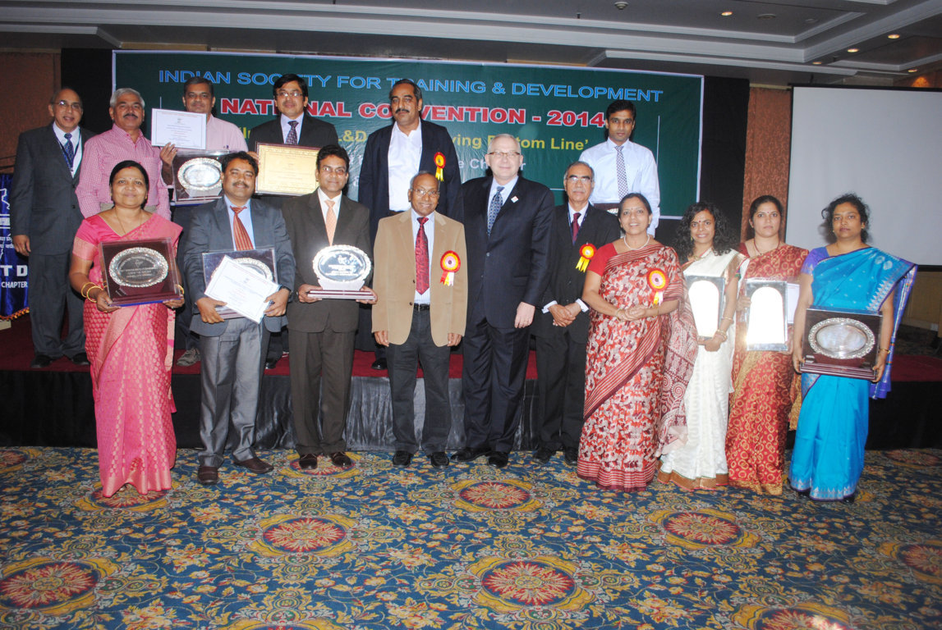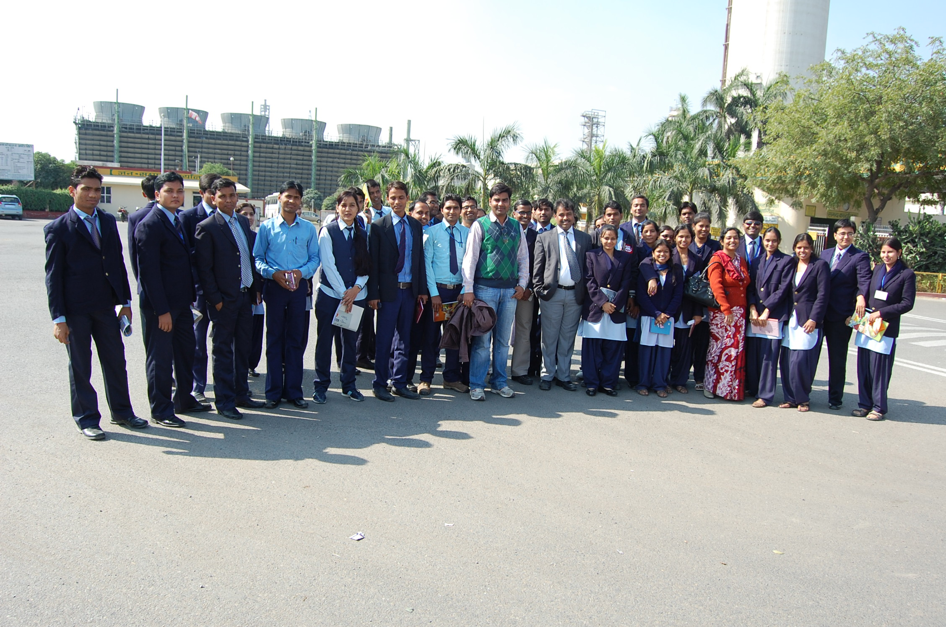
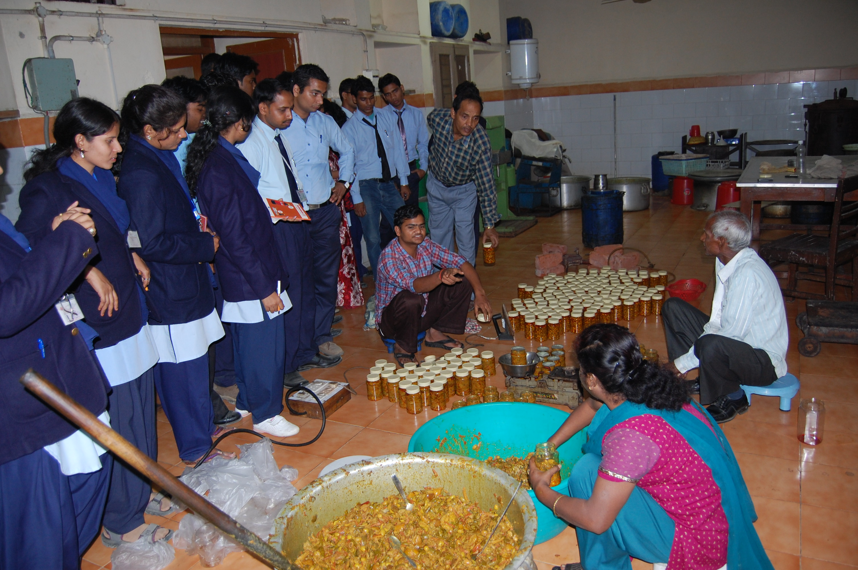

Alumni’s of FMS
…………………………………………What our Alumni speaks
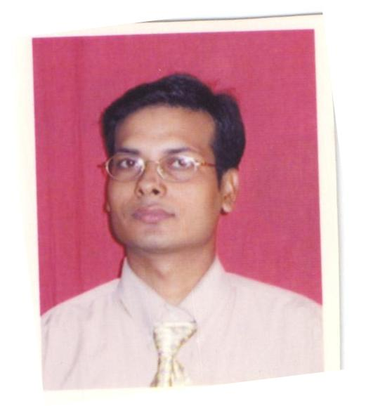
Pankaj Tiwari, MBA (Business Economics)
Asistant Professor, Department of Finance
National Fiji University,FIJI

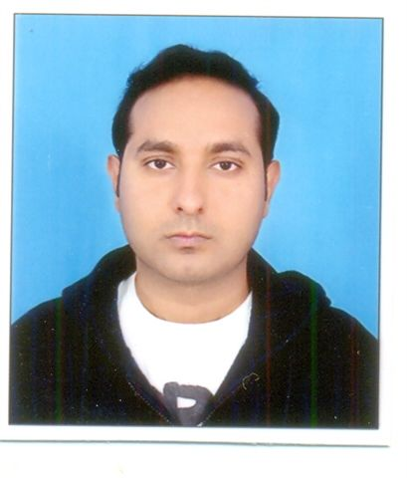…………..department has immensely supported to develop my career.
Deepak Pathak, MBA (Business Economics)
Deputy Manager
Creative Portico (India) Pvt. Ltd., Vapi, Gujarat

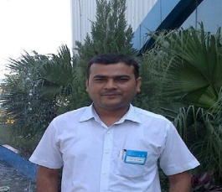
SANDEEP KUMAR UPADHYAY, MHRD
Middle Management – Human Resource
Delphi-TVS Diesel Systems Ltd.
Uttarakhand-263153

..the department has helped me achieve my dreams.
Dr Sushil Singh ,MBA(Business Economics)
Asst Prof, IGNTU Central University, Amarkantak
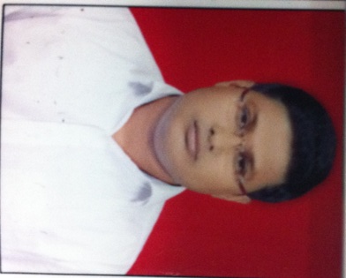
Nishant Singh,MBA
Sales Manager – Institution (All India)
Kellogg India Pvt. Ltd.
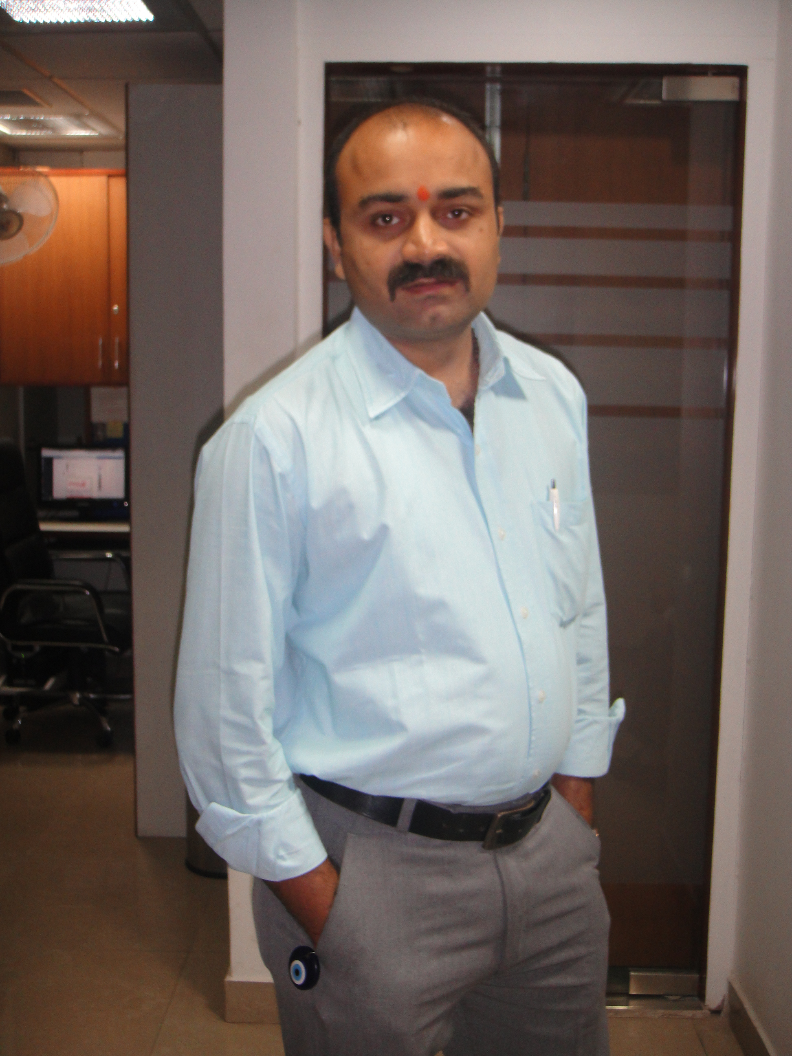
Prateek Pandey, MBA (HRD)
HR-Manager
Cardinal Technology Solutions Pvt. Ltd.

 …………..Department has given a new dimension to my carreer. I am very grateful to my faculty members for enhancing my personality.
Pranav Mishra, MBA (Business Economics)
HOD, Deptt. of Management at Lingaya's Lalita Devi Institute of Management & Sciences.
New Delhi.



Lalit Kant Singh, MBA(HRD)
Manager – HR
M/s. Inckah Infrastructure Technology Pvt. Ltd"

Placement Activities
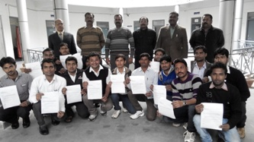
Final year students with the joining letter of Sohan Lal Commodity Mgmt Pvt Ltd

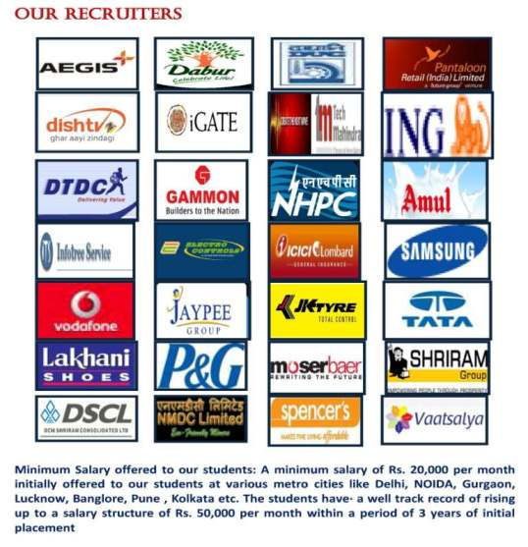

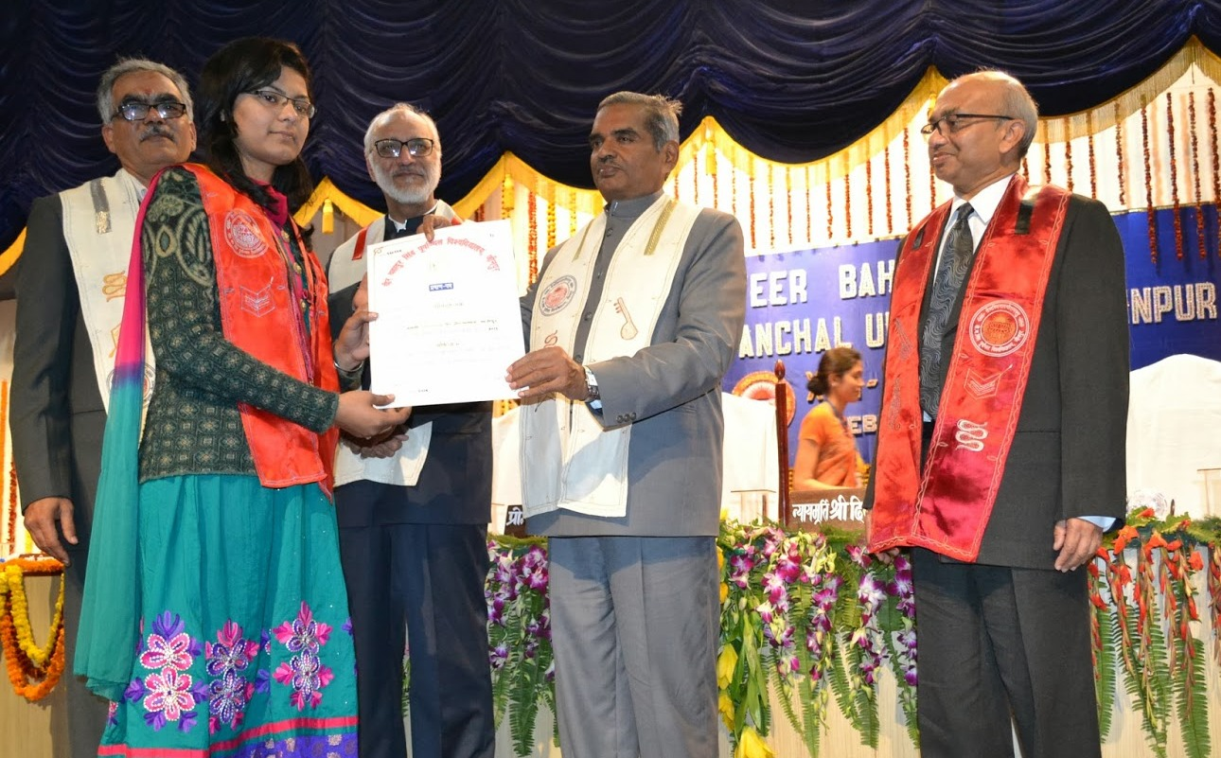Guests Honoring the gold medalist at the occasion of 17th convocation 2014

Important Dates
Last Date for Submission of application form to the University | April 07, 2014
Date of Admission Test | May 11, 2014
Declaration of Result | May 20,2014

Completed Form Should be sent to :

Prof.BB Tiwari
Chairman, Admission Cell
Professor in Electronics and Communication Engineering
VBS Purvanchal University Jaunpur-222003 (U.P)
Mo.No. : +91-9161368540

