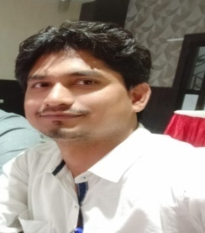
Deepak Kumar Singh,
Assistant Professor,
Department of Electronics & Communication Engineering,
Class Counselor/Mentor, ECE Final Year
UNSIET, VBS Purvanchal University, Jaunpur, U.P.
Email: deepaksinghvbspu@gmail.com

Life discipline: Punctual, dedicated towards responsibilities, hard-working, supportive, positive reinforcement.

Qualification: B Tech (E & C Engineering, 2010, UPTU Lucknow), M Tech (E & C Engineering, 2017, AKTU Lucknow), and Ph D (Pursuing, VBS Purvanchal University, Jaunpur)

Experience: 12 years of teaching experiences in reputed organization at UG and PG levels.

Interests & Specialization:
- Free Space Optics/Hybrid Free Space Optics-Radio Frequency
- Fiber Optics & Photonics
- Electromagnetic Theory
- Wireless Communication
- Analog & Digital Communication

Membership of Professional bodies:
- Member IEEE Graduate Student
- Member IEEE Photonic Society
Organised one International Conferences in 2020 at Jaunpur, namely “ICEECS-2020”.
Organised one Faculty Development Program at Jaunpur, namely “Recent advances in Communication & Photonics”.
Published 02 research papers of repute in National & International Journals.
Published 03 research papers of repute in International Conference like Springer, IEEE, etc.
Participated in 07 national & international conferences/workshops at IITs, IEEE.
Attended 50+ training, short term course, workshops, symposium and FDPs programs in IITs, IIIT, IEEE Society and Industries all over country.

