CURRICULAM VITAE

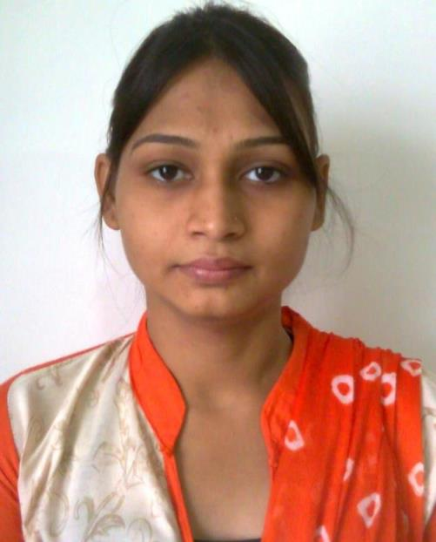

POONAM SONKAR
MOH- SAIYADALIPUR POST-SADAR
DIST- JAUNPUR
STATE- UTTAR PRADESH
Mobile-9369494969, 8896886261
E-mail- poonampms@yahoo.com

Objective and Vision

Seeking a challenging and growth oriented career enhancement, where I can utilise my skills and knowledge with the opportunity for professional growth and to excel by contributing towards the achievement of organizational goals.

_______________ Professional snapshot ______ __ _

- Designated as Lecturerin Department of Electronics and Communication (ECE) in Veer Bahadur Singh Purvanchal University Jaunpur. (2013-till now)

- Designated as Lecturer in Department of Electronics and Communication (ECE) in Pt. Laxmikant Upaddhayay Engeneering Institute of Technology.(2011-2012)

Organizational Experience

- Subjects Taught: Wireless and communication, Transducer and Sensor, Electronic measurement and instrumentation, Data communication and network, Electromagnetic field and theory, Biomedical and Instrumentation
- Conducing presentations, PDP sessions & seminars on regular basis
- Organizing and managing cultural activities of the college as an active member of the Cultural Committee
- Adapting innovative teaching methods including quiz sessions, assignments, group activities, pre-lecture notes, regular class tests, real-life examples, regular class exercise.
- Constantly communicating with parents/guardians regarding the progress of the students

Dissertation work
- Organization: BabuBanarasiDas University Lucknow.
- Dissertation on: Cooperative Communication.
- Platform used:MATLAB
- Duration :1 Year.

Paper Published

S.No. | Title of paper | Name of journal and publication | Status
1 | Rural Empowerment through Broadband | National conference IETE Lucknow | 2013 Presented
2 | Cooperative Diversity Analysis using DF Relay Network Over Rayleigh Fading Channel-I | National conference COTII | 2014 Presented
3 | Cooperative Diversity Analysis using DF Relay Network Over Rayleigh Fading Channel | IJIRCCE | Volume 3, Issue 10, October 2015 ISSN(Online): 2320-9801  ISSN (Print): 2320-9798
4 | A Review on Cooperative Communication with Relay | IJIR | Vol-2, Issue-5, 2016  ISSN: 2454-1362

Projects undertaken
- Organization: IET, Purvanchal University Jaunpur.
- Project Title:Annuciation system.
- Duration :6 months

Summer Training
- Organization : Cotmac Pune
- Project Title : PLC design
- Duration : 4 weeks

Educational Qualification _

Master Of Technology (2014)
(M.Tech.): Wireless and Communication
:BabuBanarasi Das University Lucknow
: 75%

Bachelor Of Technology (2008)
(B.Tech) : Electronics & Instrumentation Engineering
:UNSIET VBS Purvanchal University Jaunpur, UTTAR PRADESH
: 67%

12th(2004) : MaaDurgaJiVidyalayajaunpur
(C.B.S.E) : 56 %

10th(2002) : Gyanda High School Jaunpur
(U.P.) : 65%

Personal Information _

Age and date of birth : 07/06/1987
Father’s Name : JainarayanSonkar
Nationality : Indian
Marital Status : Single
Languages known : English, Hindi

DECLARATION _

I hereby declare that all details given above are true to the best of my knowledge and belief.

Date………………..

Place………………... Signature

