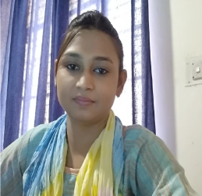
Poonam Sonkar
Assistant Professor,
Department of Electronics and Instrumentation
Uma Nath Singh Institute of Engg and Technology
VBS Purvanchal University, Jaunpur, U.P.

Life discipline – Punctuality is more valuable, Honest about job, Never support wrong things.
Qualification:
B.Tech (Electronic and Instrumentation UNSIET VBSPU,Jaunpur) – First Division Hons.(65.7 %)in 2008.
M Tech (Wireless and Communication Babu Banarasi Das University Lucknow) – (74.3) in 2014.

Teaching Experience-
- Lecturer in Electronic & Communication Engineering department in “UNSIET VBSPU Jaunpur” from 2013-2015.
- Lecturer in Electronic & Instrumentation Engineering department in “UNSIET VBSPU Jaunpur” from 2015-2018
- Assistant Professor in Electronic & Instrumentation Engineering “Uma Nath Singh Institute of Engineering and Technology” , VBSPU, Jaunpur from October 2018 to till date.

Interests & Specialization
1. Wireless and Communication.
2. Control Systems.
3. Transducer and Measurement.
4. Digital Electronic

Membership of Professional bodies
Member of team of organisers for International Conferences in 2020 at Jaunpur.
Coordinator and organizer of various events like Science Day, Engineers Day, etc
Coordinator of various students’ activities like Summer Internship for 2nd year students in 2019 and Induction Program for 1st year students in 2019 and 2020
Participated in more than 40 in house and outside workshops and FDPs
Attended 20+ training, short term, FDPs programs in IITs, IIM, and Industries all over country.

