Mr. Vishal Yadav
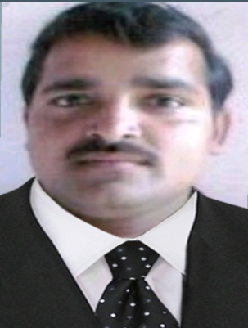
Assistant Professor
Department of Electronics Engineering,
Uma Nath singh Institute of Engg and Technology
VBS Purvanchal University, Jaunpur, U.P.

Life discipline – Confident, Patience, Energetic, Persistent and Tenacious.
Email Id: vishalunsiet@gmail.com
Qualification:
B.Tech (Electronics and Instrumentation Engg.-UNSIET VBSPU JAUNPUR) – First Division (68%)in 2009.
M Tech (VLSI Design, SIET Jhalawa Allahabad(AKTU Lucknow)) – First Divison(72%) in 2014.
Ph D Pursuing from VBSPU Jaunpur.
Teaching Experience-
- Assistant Professor in “Uma Nath Singh Institute of Engineering and Technology” , VBSPU, Jaunpur from 26 April 2010 to till date.

Interests & Specialization
- VLSI Design
- Transducer and Sensor
- Electronics Engineering
- NCER
- EIM
- Industrial Instrumentation
- VLSI Technology
- ICT

Membership of Professional bodies
Coordinator of Faculty Development Programs at Jaunpur, namely Recent advances in RF & Photonics.
Coordinator and organizer of various events like Science Day, Engineers Day, etc.
Coordinator of various students activities like Summer Internship for 2nd year students in 2019. Coordinator of Induction Program for 1st year students in 2019 and 2020.
Participated in more than 20 in house and outside workshops and FDPs.
Attended 15+ training, short term, FDPs programs in IITs, IISc, and Industries all over country.

