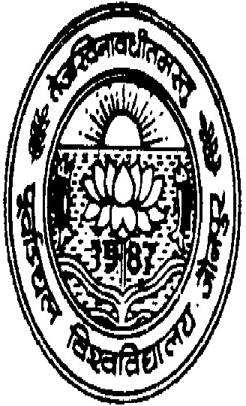
ohj cgknqj flag iwokZ™py fo'ofo|ky;] tkSuiqj
i=kad% 542@xksiuh;@16 fnukad% 07-12-2016

lwpuk
,rn~}kjk loZlk/kkj.k dks lwfpr fd;k tkrk fd o"kZ 2016 dh ijh{kk ds lfUujh{kk ¼LØwVuh½ gsrq “ks’k fo|kfFkZ;ksa dh mÙkjiqfLrdkvksa dh lfUujh{kk ds mijkUr fooj.k fuEuor~ gS %&

Ø-la- | d{kk | vuqØekad | fo’k; | iz”ui= | izkIrkad | lfUujh{kk ds vad
1 | B.Sc.I | 16620407304 | PHYSICS | III | 8 | No Change
2 | B.Sc.I | 16601403295 | ZOOLOGY | III | 2 | No Change
3 | B.Sc.I | 16607405532 | Industrial CHEMISTRY | I | 9 | No Change
4 | B.Sc.I | 16607405532 | Industrial CHEMISTRY | III | 20 | No Change
5 | B.Sc.I | 16413400054 | ZOOLOGY | III | 17 | No Change
6 | B.Sc.I | 16601404027 | MATH | III | 25 | No Change
7 | B.Sc.I | 16620407876 | ZOOLOGY | II | 0 | No Change
8 | B.Sc.I | 16466401835 | ZOOLOGY | II | 8 | No Change
9 | B.Sc.II | 16620387258 | MATH | II | 2 | 8
10 | B.Sc.III | 16607375286 | CHEMISTRY | II | 15 | No Change
11 | B.Sc.III | 16622376417 | CHEMISTRY | II | 19 | 20
12 | B.Sc.III | 16612375485 | CHEMISTRY | II | 15 | 16
13 | B.Sc.III | 16618375889 | PHYSICS | III | 19 | No Change
14 | B.A I | 16217010217 | EDUCATION | II | 0 | No Change
15 | B.A I | 16675097990 | GEOGRAPHY | II | 7 | No Change
16 | B.A I | 16729107329 | HINDI | I | 30 | No Change
17 | B.A I | 16729107364 | HINDI | I | 26 | No Change
18 | B.A I | 16521068159 | HINDI | I | 0 | No Change
19 | B.A I | 16269021469 | HINDI | I | 31 | No Change
20 | B.A I | 16650092479 | HOME SCIENCE | I | 18 | No Change
21 | B.A I | 16413048168 | MUSIC (GAYAN) |  | 4 | No Change
22 | B.A I | 16652093142 | POLITICAL SCI. | I | 22 | No Change
23 | B.A I | 16440055111 | SANSKRIT | I | 51 | 62
24 | B.A I | 16601076401 | SOCIOLOGY | I | 33 | No Change
25 | B.A I | 16313030894 | SOCIOLOGY | I | 25 | No Change
26 | B.A I | 16406044421 | URDU | I | 2 | No Change
27 | B.A II | 16622310309 | ANC. HISTORY | II | 39 | No Change
28 | B.A II | 16710326903 | GEOGRAPHY | I | 10 | No Change
29 | B.A II | 16313264659 | SANSKRIT | II | 22 | No Change
30 | B.A II | 16257253341 | SOCIOLOGY | I | 26 | No Change
31 | B.A II | 16633311256 | SOCIOLOGY | II | 13 | No Change
32 | B.A III | 16857233952 | GEOGRAPHY | I | 0 | UFM
33 | B.A III | 16633201662 | GEOGRAPHY | II | 19 | No Change
34 | B.A III | 16629200863 | HOME SCIENCE | I | 22 | No Change
35 | B.A III | 16690214398 | HOME SCIENCE | II | 20 | No Change
36 | B.A III | 16531188624 | URDU | I | 25 | 29

izfrfyfi %& fuEufyf[kr dks lwpukFkZ ,oa vko”;d dk;Zokgh gsrq izsf"kr & dqylfpo
- futh lfpo dqyifr] ekuuh; dqyifr th ds lwpukFkZA
- izkpk;Z] lEcfU/kr egkfo|ky;A
- izHkkjh M.I.S. lsy dks bl vk”k; ls izsf"kr fd fo”ofo|ky; osclkbM ij Hkh mDr lwpuk viyksM djus dh d`ik djsaA
- izHkkjh] ijh{kkQy izdk”ku ,tsUlhA

dqylfpo

