Application No.......
V.B.S. Purvanchal University, Jaunpur -222003, UP
(A NAAC Accredited University)
Fax.: (05452) 252344,252244

Email:connectpuregistrar@gmail.com Web: www.vbspu.ac.in

i=kad& 554@lkek0iz'kk0@2019 fnukad 04@10@2019
APPLICATION FORM
(Corrigendum No. 360/सामा०प्रशा०/2019 Date: 28/05/2019for RajjuBhaiya Institute)
(Corrigendum: 361 /सामा०प्रशा०/2019 Date: 28/05/2019for Eng&Tech/ Biotech)
(Advt No: 362/सा.प्रशा./2019 Date:28/05/2019for Management/MAP/MCJ/MCA)

LAST DATE FOR RECEIPT OF APPLICATION: 6 November 2019(Wednesday) at 5.00 PM
(Only for the post of Associate Professor and Professor)
Paste recent Colored Passport Size Photograph
Overlap with Signature

Do Not Staple
Bank Draft Details | Amount (Rs.) | Name of the Bank | Issuing Branch Name
DraftNo:
Date:

Tick (√) the Category: | UR | SC | ST | OBC | DA

(Please attach certificate in support)
Post Applied for |  | :
Name of Department |  | :
Specialization (if any) |  | :
Advertisement No |  | :
1. GENERAL INFORMATION
 | Name of the Applicant  (In block letters) | :
 | Father's/Husband's Name | :
 | Date of Birth
 | Mobile Number | :
 | Email Id
 | Correspondence Address | :
 | PermanentAddress | :
 | Present Post/Designation | :
 | Present Pay Scale  /Basic Pay Band + AGP if Applicable | :
 | Current Basic Pay | :
 | Name of institution/  Organization | :
 | Language Known (Read , Write /Speak)
 | Gender and Marital Status
(i) Male/Female |  | :
(ii) Married/Unmarried |  | :
(iii)If married, give the full  name of Spouse |  | :

2. ACADEMIC QUALIFICATIONS

a. Academic Background
Examination Passed | Board/University/ Institute | Year of Passing | Regular/ Private | Subject (s)/  Specialization | Division/ Grade * | %age of Marks | Encl.  No.
High School (10th)
Intermediate (12th)
Graduation
B.Sc./BCom/B.Tech/BE /BCA/BBA etc.
Post-Graduation
M.Sc./MA/MCA/ M. Techetc
M.Phil

Ph.D./D.Phil
D.Lit./DSc.
Others (if any)
Certificate in Office Automation
* Please Attach the conversion of Grade into percentage (Mandatory)

b. | Have you qualified NET/SLET/SET?  (If yes, please give details with Roll No) | :
c. | Ph.D. Topic | :
 | Date of Registration of Ph.D. Degree | :
 | Date of Award of Ph.D. Degree  (Attach UGC Regulation 2016 4th amendment if applicable) | :
d. | D.Lit. Topic | :
e. | Technical Qualification, if any | :
f. | Area of Specialization/Field of Research | :
g. | Academic distinction  (e.g. any prize, medal, honor, award etc.) | :
h. | Foreign visits for academic purpose  (If any, please give details). | :
i. | Have you been punished during your  studies at College/University  (if so give details) | :

3. TEACHING EXPERIENCE

- Give thedetails of Regular employment on pay scale (in chronological order)

Designation/ Post Held | Name of Institution | Exact Dates/ Period |  | Scale of Pay + AGP | Nature of duties | Encl. No.
 |  | From | To

b. | Total Teaching Experience
 | (i) Under Graduate |  |  |  |  |  | : |  | Years |  |  |  |  |  |  | Months
 | (ii) Post Graduate |  |  |  |  |  | : |  | Years |  |  |  |  |  |  | Months
c. | (i) Break in Service, if any  (Indicate the period giving reasons) |  |  |  |  |  | : |  | Period  Reasons ................................................
 | (ii) Have you been punished duringyour services? If so, give details.
(iii) Do you have any court casespending as one of the parties?...................
(If yes, give details)

d.Research Experience
(Excludingfull time Ph.D./D.Phil or M.Phil enrolment period)YearsMonths
e.Administrative/AcademicResponsibilities, (if any)

Name ofthe Institution |  |  |  | Designation |  | Nature of Assignment |  |  |  | Dates/Periods |  |  |  |  |  |  | Length of Experience |  |  |  | Encl. No
 |  |  |  |  |  |  |  |  |  | From |  | To |  |  |  |  | Years |  | Months
f.Details of Courses Attended (Please enclose evidence)

S.No. |  | Name of the Course |  |  | Organizing Body /University |  |  |  |  |  |  |  |  | Duration |  |  |  |  |  | Encl. No
g. Membership of Professional Bodies/Societies etc.

S.No. |  | Name of the Society/Bodies |  |  |  |  |  |  |  |  |  |  |  | Memberships |  |  |  |  |  | Encl. No
h.Disclosure
S.No. |  | Details |  |  |  |  |  |  |  |  |  |  |  |  | Yes/No |  |  |  |  | Encl. No
 |  | Have you every been punished for Gender/Caste related offences or convicted by a court of Law? If yes, give details
 |  | Were you have any criminal case pending against you in a court of law? If yes, give details.
i. Period of Extra Ordinary Leavewithout pay (If availed) |  |  |  |  |  |  |  |  |  |  |  |  |  |  |  |  |  |  |  | Encl. No
j.Two References familiar with your academic work
S.No. |  | Full Name | Institution Affiliation (Present/Former) |  |  |  |  | Designation |  |  | Address |  | M.No/Phone No |  |  |  |  | Email |  |  |  | Encl. No

4. UGC regulations on minimum qualifications for appointment of teachers andother academic staff in universities and colleges and measures for themaintenance of standards in higher education, 18 July 2018 and UP Govt. OrderNo. 600/सत्तर-1-2019-16(114)/2010 dated 28 June 2019.

* Minimum research score is required Seventy-five (75) for Associate professor and One Twenty (120) for professor
CATEGORY 1: Research Papers Published in peer-reviewed or UGC listed Journals
S.N. | Title with page/volume Nos. | JournalNameISSN/ISBN No. | Refereed/ReputedJournal | Impactfactor as per Thomson Reuters List, if any | No. ofCo-authors | Main/ Corresponding author | Research score Claimed | Encl.  No

CATEGORY 2 Publications (Other than Research Papers)
(a) (i)Books Published (As Authors/Editor)
S.N. | Book Title | Type of  Authorship | ISSN/  ISBN No. |  | Publisher (International/ National/ State/Govt. Publisher) |  | Type of Book (Text/ Reference/ Subject etc) |  | No. of  Coauthors |  | Main/ corresponding author |  | Academic/  Research Score |  | Encl.  No
(ii) Articles/Chapters Published in Books:

S.N. | Title ofArticle/  Chapterwith Page Nos. | Book Title |  | ISSN/ISBN No. |  | Type of Book(Text/Reference/  Subject etc) |  | Publisher(International/National/ State/Govt. Publisher) |  | No. ofCoauthors |  | Main/ corresponding author |  | Academic/Research Score | Encl.No
(b) Translation Works in Indian and Foreign Languages by qualified faculties:
S.N. | Title of  Chapter/Research with Page Nos. | Book Title |  | ISSN/ISBN No. |  | Type of Book (Text/Reference/Subject etc) |  | Publisher (International/ National/ State/Govt. Publisher) |  | No. of Coauthors |  | Main/ corresponding author |  | Academic/Research Score | Encl.No

CATEGORY 3. Creation of ICT mediated Teaching Learning pedagogy and content development of new and innovative courses and curricula

S. No. | Category | Sub Category | Credits | Name of the Module | Subject | Organization for which it was developed | Year | Level  (UG/PG/  Research etc) | Link  (Website) | Academic/  Research Score | Encl. No.

CATEGORY 4 (a) Research Guidance:
S.No. |  |  | Research Supervision |  |  | Ph.D. Thesis Submitted  (No of Candidate) |  |  |  |  | Degree Awarded (No of Candidate) |  |  | Academic /  Research Score |  |  |  |  | Encl. No
 |  |  | Ph. D.
 |  |  | M. Phil/P.G. Dissertation
(b&c). Research Projects (Sponsored Projects) :

S.N. |  | Title of Project |  |  | Funding  Agency |  |  | PI/CoPI | Period |  | Grant / Amount mobilized less than or Greater than >10  (Rs. Lakhs) |  | Completed  / Ongoing |  |  | Outcome | Academic/  Research Score |  |  |  | Encl. No.
(d) Consultancy Projects:

S.N. | Title |  |  | Agency |  |  | PI/CoPI |  |  | Period |  | Grant/Amount Mobilized (Rs. Lakhs) |  |  | OutCome |  |  | Academic /Research Score |  | Encl. No.

CATEGORY 5 (a). Patents:
S.N. | Title |  |  | Agency |  | Main/Co-Inventer |  | Period |  |  | Project Outcome /Technology Transfer etc. |  |  | International /  National |  |  | Academic /Research Score |  |  | Encl. No.
(b). Policy Document
S.N. | Title |  | Agency |  |  |  | Period |  | Policy Document Submitted to an International body/organization like UNO/UNESCO/World Bank / International Monetary Fund etc./Central Government/State Government |  |  |  | International /  National/State |  |  | Academic /Research Score |  |  | Encl. No.
(c) Awards:/ Fellowships
S.N. |  | Award /Fellowship  Name |  |  | Whether International/National |  |  |  |  | Name of Academicbody/ Association |  | Date |  |  | Academic/Research Score |  |  | Encl. No.

CATEGORY 6*Invited Lectures/Resource Person/ Paper Presentation in Seminars/ Conferences/ Full Paper in Conference proceedings

S.N. | Title of the invited Lecture /Paper presentation | Title of the conference/ Seminar/Symposium etc. | Organized by | Date of presentation | Whether International (Abroad) / International (within country) /National /State/ University Level | Invited or paper presented | Academic/Research Score | Encl. No.

SUMMARY OF ACADEMIC/RESEARCH SCORE:
Category | Criteria | Total Academic/Research Score (Claimed by Applicant) | Total Academic/Research Score for Assessment  (Verified)
 | Research Papers Published in peer-reviewed or UGC listed Journals
 | Publications (Other than Research Papers) Books/Chapter + Translation
 | Creation of ICT mediated Teaching Learning pedagogy and content development of new and innovative courses and curricula
 | ICT mediated Teaching Learning pedagogy and content development of new and innovative courses and curricula
 | Patents: +Policy +Awards/Fellowship
 | Invited Lectures/Resource Person/ Paper Presentation in Seminars/ Conferences/ Full Paper in Conference proceedings

Please give details of any other credential, significant contributions, awards received etc. not mentioned earlier.

S.N. | Details (Mention Year, Value etc. where relevant) | Enclosure

No Objection Certificate

I shall produce the No Objection Certificate before /at the time of Interview failing which you may not be allowed to appear for interview.

DECLARATION

I ………………………. S/O, D/O………………….hereby declare that all the statements and entries made in this application are true, complete and correct to the best of my knowledge and belief. In the event of any information found false or incorrect or ineligibility being detected at any stage, my candidature/appointment may be cancelled by the University.
I have never been convicted or penalized for any unlawful activity by any Institution/Court.

Place: Signature of the applicant
Date:

ENDORSEMENT BY THE PRESENT EMPLOYER:
Forwarded to:-The Registrar, V.B.S. Purvanchal University, Jaunpur-222003 (U.P.)
The applicant.……………………….. S/o, W/F, D/O,……………………..who has submitted this application for the post of …………………………….in Department of ………………in the ………………………………………. has been in employment …………………………………………………. in a Permanent capacity with effect from …………………………in the Pay Scale of Rs………………………….. Presently He is drawing a basic pay of Rs…………………………....His next increment is due on ………………………………..
Further, it is certified that no disciplinary query has ever been held or pending against the said applicant. There is no objection for his/her application being considered by the V.B.S. Purvanchal University, Jaunpur-222003, and in the event of selection, he/she will be relieved to join the V.B.S. Purvanchal University, Jaunpur-222003as per rules.

Date: Signature..................................

Name………………………….

Seal of Head of the Institution

SUMMARY SHEET (2 SET)

1. Post applied for : |  |  |  | 2. Department:
3. Name:  (BLOCK Letters) |  |  |  | 4. Male/ Female/Transgender |  |  |  |  |  | 5.Married/ Unmarried
6. Date of birth | 7. Place of birth: |  |  |  |  |  | - Category: GEN/OBC/SC/ST/ DA
9. Educational Qualification | Name of the  course | Name of the  Board/University |  |  |  |  | Month & Year  Passed/ Award |  |  | Division |  | % of  Marks |  | CGPA
10th Class. / equivalent
10+2/Higher Secondary equivalent
Bachelor's Degree

Master's degree

M.Phil./ equivalent

Ph.D./D. Phil. |  |  |  |  |  |  |  |  |  | Title:
NET/SLET/SET with Roll no
10. Chronological List of Earlier Positions/Appointments
Designation &  Scale of pay | Name & Address of Employer |  | From date |  |  |  |  | To date |  |  | No. of years/  months |  | Nature of  Work/Duty
11. Teaching Experience | No. ofyears |  | No. ofmonths |  |  |  |  | 12. Publications |  |  | Published [ISBN/ ISSN] (Nos.)
i) Under-graduate level |  |  |  |  |  |  |  | Books
ii) Post-graduate level |  |  |  |  |  |  |  | Research Publications
Post-doctoral Teaching/ Research |  |  |  |  |  |  |  | Other Publications
13. Invited Lectures/ Paper presentation in Seminars/Conferences |  |  |  |  | 14. Research Guidance |  |  |  |  | M. Phil./P.G.  (No.) |  | Ph.D./D. Phil.  (No.)
National (No.) | International (No.) |  | Total (No.) |  |  | Completed
 |  |  |  |  |  | Under Supervision
15. Fellowship/ Awards |  |  |  |  | 16. Research Projects
National (No.) | International (No.) |  | Total (No.) |  |  | Sponsored |  |  |  |  | Consultancy |  | Patent etc
17. PresentDesignation | Name of University/  Institutions |  | Basic Pay (Rs.) |  |  |  |  | Pay Scale |  |  | Gross /  Total Salary  P.M. (Rs.) |  | Increment date  (Date/ month)
18. Academic/Research
Category-1 | Category-2 |  | Category-3 |  |  |  |  |  | Category-4 |  | Category-5 |  | Category-6 |  | Total

(Signature of the Applicant)

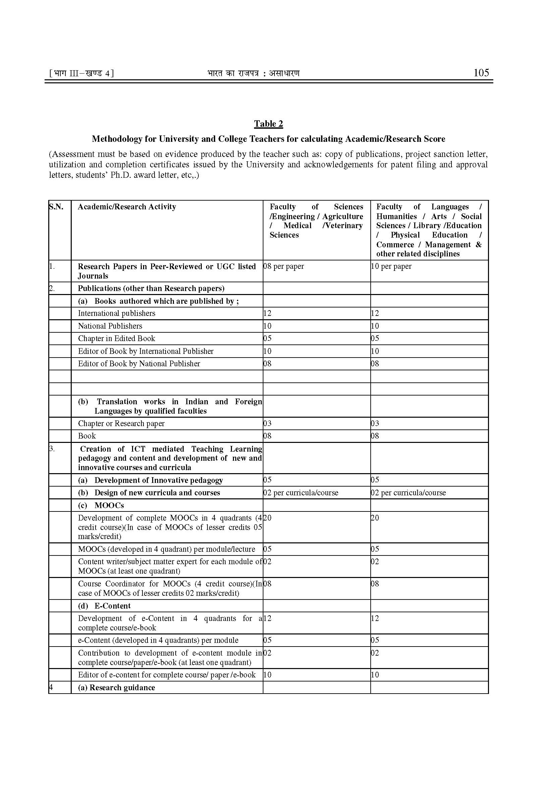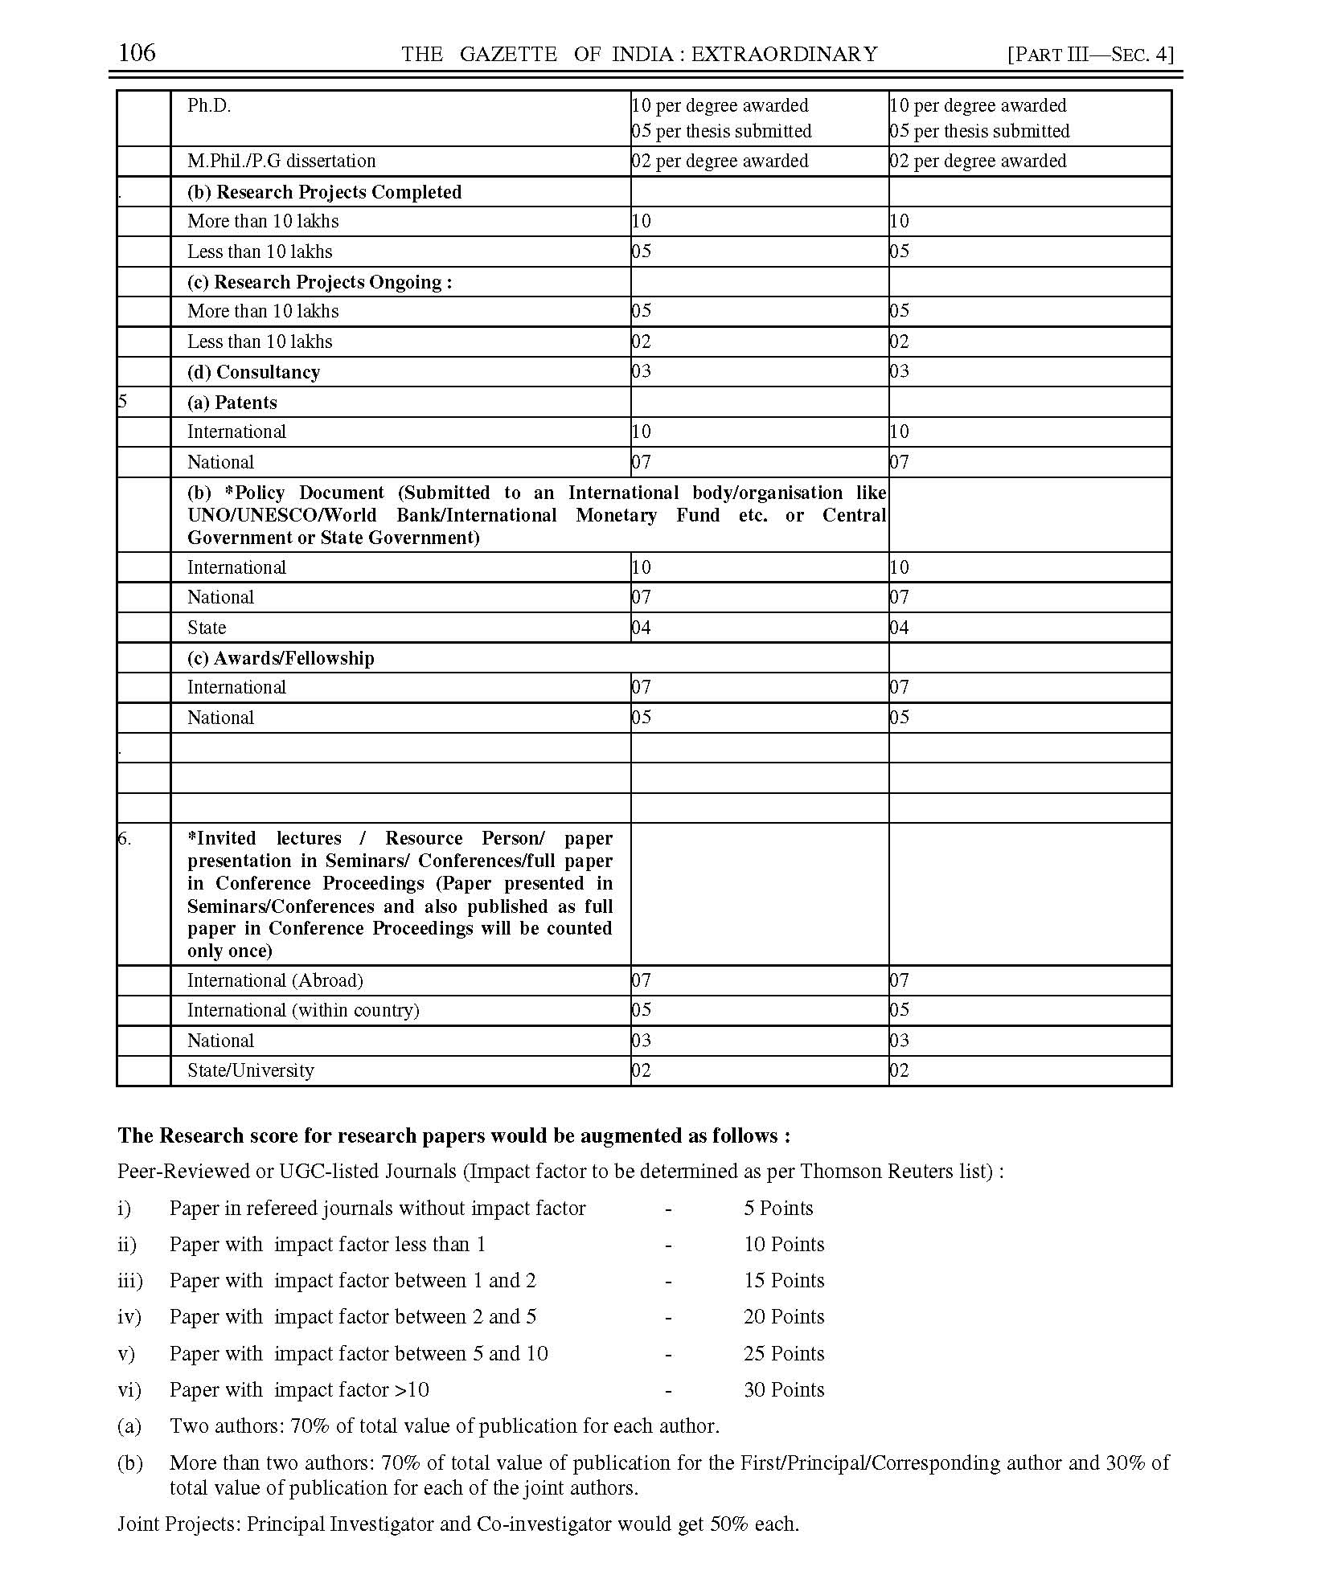
Note:
  - Paper presented if part of edited book or proceeding then it can be claimed only once.
  - For joint supervision of research students, the formula shall be 70% of the total score for Supervisor and Cosupervisor. Supervisor and Co-supervisor, both shall get 7 marks each.
  - *For the purpose of calculating research score of the teacher, the combined research score from the categories of 5(b). Policy Document and 6. Invited lectures/Resource Person/Paper presentation shall have an upper capping of thirty percent of the total research score of the teacher concerned.
  - The research score shall be from the minimum of three categories out of six categories.

